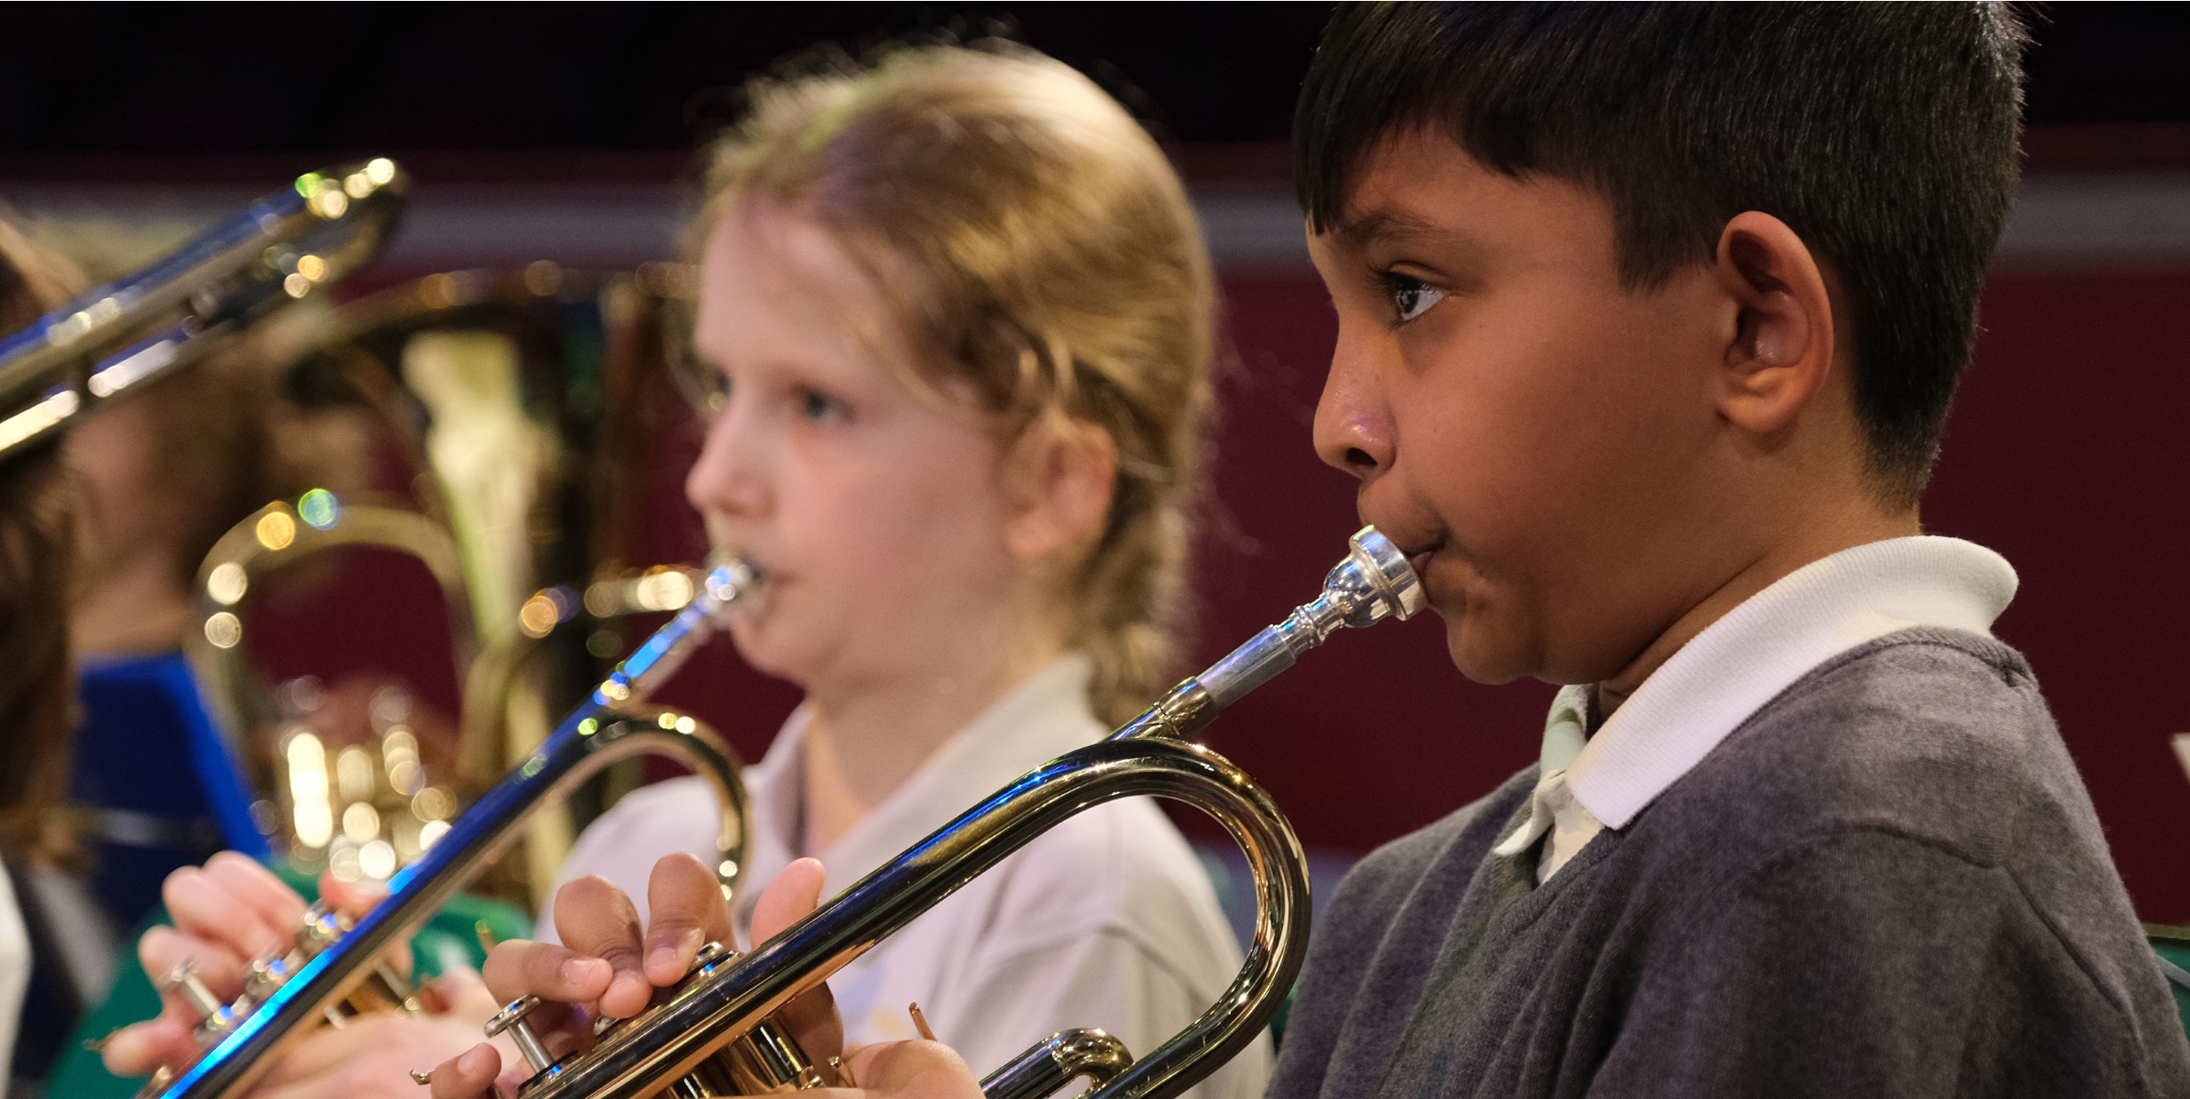
Camden Music is delighted to offer a wide range of
one to one and shared music lessons in your school.

Getting started is easy!

Simply go to our website for more information and to
register.

Why not sign up for an exciting weekend or
holiday group as well?

www.camden.
g
ov.uk/camdens-music-servic
e

LESSONS IN SCHOOL
S
SATURDAY CENTRE
S
SUNDAY GROUP
S
HOLIDAY COURSE
S

020 7974 7239
camdenmusic@camden.gov.uk

