School Partnership

Maths Policy
Policy produced by school1.9.23

Adopted by Governors FGB-Academic year 25/26
Review date- As changes are made

Intent of our curriculum

Curriculum design

A high quality maths curriculum will ensure that pupils:

- become fluent in the fundamentals of mathematics, including through varied and frequent practice with increasingly complex problems over time, so that pupils develop conceptual understanding and the ability to recall and apply knowledge rapidly and accurately.
- reason mathematically by following a line of enquiry, conjecturing relationships and generalisations, and developing an argument, justification or proof using mathematical language
- can solve problems by applying their mathematics to a variety of routine and non-routine problems with increasing sophistication, including breaking down problems into a series of simpler steps and persevering in seeking solutions
- can speak about what they have learned in a knowledgeable and articulate way, using their ‘public voice’.

We always start with the National Curriculum.

Teachers follow White Rose Maths Schemes of Work which have been written in line with the National Curriculum.

Teachers refer to the curriculum map and to the White Rose Scheme of Work. They
read this to be clear on what they have to teach and how they have to teach it (the White Rose Maths Scheme of Work outlines the resources to use and the visuals that will support teaching) in order for children to reach the expected national standards. We always aim to teach all of our class at the expected national level (except those with SEND), and support lower attaining children to reach that level.

Teachers plan directly from the White Rose Maths Scheme of Work. White Rose Maths is a Scheme of Learning that is designed to provide an example overview of a year’s teaching sequence, broken down into a series of ‘small steps’ to support teachers plan lessons. Teachers decide on what they will do over a series of lessons in order for the children to grasp the objectives outlined in the ‘Small Steps’. The teacher will consider how to split the learning up into manageable chunks i.e. they think about the component parts that need to be taught in order to reach the composite learning. What will be the A to B to C of the lessons, both over one lesson and over the series of lessons? This means how will the teacher present new material in small steps with pupil practice after each step. Teachers need to limit the amount that is delivered at one time to minimise strain on to the child’s working memory. This means they will think carefully about what they will model and what the children will practise in order to meet the learning objectives. Teachers think about how they will deepen the learning for the children. Teachers consider what are the key questions which they can use to recall prior learning and then to assess what the children’s new learning has been. They consider how they will get children to problem solve and reason. Teachers also consider which mental strategies they will practise which will support the children to become fluent.

In order that pupils have enough opportunity to reason and problem solve, White Rose provide problem solving and reasoning resources for every ‘Small Step’ of Learning. They also provide a bank of resources for every year group organised termly of Problem Solving and Reasoning Questions. Teachers also have access to a Maths folder in the maths shared area called Problem Solving and Reasoning Resources with a bank of high-quality resources, question stems and activities that support good problem solving and reasoning. It is important that teachers acknowledge how much problem solving and reasoning is at the heart of good maths teaching and build this into their lessons.

Times Tables
We ensure that there is a focus on times tables and children learning these off by heart, both chanting the times tables and knowing the multiplication and related division facts off by heart.
By the end of Year 2, children should know X2, X5, X10 and the related division facts
By the end of Year 3, children should know X2, X3, X4, X5, X8, X10 and the related division facts
By the end of Year 4, children should know all times tables up to 12x12 and the related division facts
In Year 5 and Year 6, children should be given regular opportunity to recall the times tables up to 12x12 and the related division facts.
Teachers use regular times tables practice in maths lessons.

Maths resources to support planning
- White Rose Scheme of work breaking teaching and learning into ‘small steps’ with clear guidance on mathematical talk, varied fluency (making sure children see concepts in the concrete, visual and abstract form)
- A maths area in every classroom with high quality resources that match the resources used in White Rose Maths
- Maths folder in the maths shared area called Problem Solving and Reasoning Resources with a bank of high-quality resources, question stems and activities that support good problem solving and reasoning
- Maths folder in the maths shared area called fluency practice 10 minutes a day for Year 3 to Year 6 (Years 1 and 2 have access to White Rose Fluency Bee)
- Abacus text books (for the practice part of the lesson)
- Maths on Target books which are useful to practise what has been taught. There are text books from Year 3-6 and folders for years 1-2.
- Smartboard Notebook Interactive Whiteboard Resources on the White Rose website which supports the teaching of the ‘small steps’

Timetabling

Over a week we will teach at least four maths lessons and one arithmetic lesson.
As part of the maths lesson, there is a ten-minute slot for practising the key skills and developing fluency e.g. times tables, counting up and back on 100 square, number bonds etc with whiteboards, doubling, halving etc. Years 1 and 2 have access to Fluency Bee on the White Rose Maths website to support this part of the lesson. For Year 3 upwards, we have written a maths fluency scheme to support this part of the lesson. This ensure continuity, progression and that teachers have a wide range of resources to support this important part of maths. The teacher can choose to do this at the beginning or end of the lesson.

The daily mathematics lesson

Fluency – 10-minute practice
This is usually taught at the start of the lesson but can be at the end of the lesson.

Retrieval practice
The teacher then moves onto the main content of the lesson. The teacher begins this part of the lesson by activating relevant prior learning, in preparation for building on this in the lesson. This is called retrieval practice.

Modelling
Teachers then explain and model (exposition) the new learning clearly using think aloud strategies and worked examples. The teacher often uses scaffolds such as concrete and pictorial supports, scaffolded frames, exemplars etc.
The teacher uses steps to success with the children to support their working memory.

Guided Practice and Independent Practice
The teacher then moves into the first stage of practice whereby pupils practise the process under close guidance from the teacher before beginning any independent practice. This means that the teacher can check pupil work and provide immediate corrective feedback to pupils during guided practice to minimise errors and misconceptions. We encourage the children to explain their maths thinking clearly using partner talk, or targeted questions.

The teacher checks that pupils are obtaining a high success rate in questioning and practice – around 80% - to make sure that pupils build fluency and confidence.

We then move into the second part of practice which is independent practice. The teacher provides opportunity for independent practice to pupils who have already demonstrated success during guided practice

The independent practice is successful in building confidence and leading to knowledge and skills becoming automatic.

When the children have grasped the concept taught, they should be confident with the skill. This could be at the end of one lesson or at the end of a series of lessons over the week. Higher attainers should move quickly on to harder work/tasks and should not have to sit through multiple explanations which other children may need e.g. on day two they may have grasped the ideas from the day before or they may have grasped the content very quickly and after a few worked examples, are ready for more challenge.

We always want to go from the concrete to the pictorial to the abstract. This is very important. We know that this is what makes teaching memorable and makes the learning “stick” in the children’s minds. Concrete resources should always be available to all children. With this in mind, we provide opportunities for children to do maths out of the classroom and into the real world. Where appropriate children can measure the playground with trundle wheels, use real pie charts/graphs, use real discount offers when calculating % off sale items, mixing real paint/orange squash for ratios, sorting real objects into hoops.

There is a big focus on children being able to reason. Therefore we aim to have opportunities for reasoning in every lesson or series of lessons.

We always have a plenary. These don’t just have to happen at the end of the lesson. A class can be ‘gathered together’ during a lesson to re-focus work, ask more questions. During a plenary we target different questions at different attainment groups. We will ask the children to share their mathematical thinking and their work by explaining a good strategy with a talk partner, or quiz the children using the mini whiteboards to answer. We give opportunities to reason in the plenary too.

Children are given time to respond to marking during “fix it time” so that they can address any issues, correct or “have another try” at something they have misunderstood, learn from their mistakes and apply their new understanding. (Yr3 upwards). For Nursery, Reception and Year 1, verbal feedback is crucial alongside marking.

Arithmetic lessons
When teaching the four operations, there is progression in the methodology and in the content of what is taught using the White Rose Maths Scheme of Learning.
We always follow White Rose Maths when teaching the four operations to ensure that the children are not confused with a range of different methods and are using the correct concrete apparatus to support their understanding. It is also important for the children to have continuity and consistency in their learning from year to year. We have calculation guidance as part of our policy which directly matches White Rose, which outlines how children record standard written methods in our school so that they are not confused. This is attached at the end of this policy.
One lesson every week is devoted to arithmetic to support our children with knowing more and remembering more. The arithmetic lesson involves the children doing a range of questions on arithmetic using methods that they have been taught. The questions are presented to the children in the same format as the Year 2 and Year 6 end of key stage tests.
We start this in Year 2. In Year 2 the questions involve the four rules of addition, subtraction, multiplication and division plus fractions.
For Year 3, Year 4 and Year 5 the questions involve the four rules of addition subtraction, multiplication and division as well as fractions, decimals and percentages.
Once the children have completed the arithmetic questions, the teacher considers each question in turn together with the class. The teacher will look at how the children answered the questions, how the children worked them out, how to show any working out, standard methods etc. The teacher may need to do revision on the board, get children to have a go on whiteboards, extend the question out through discussion or get children to try a harder / different one on their whiteboards.
The children are able to use concrete resources for the lesson and the teacher keeps a record of the weekly marks in their mark book.
This allows children to have regular practice and ensure arithmetic and calculation methods are in their long-term memory.
Year 5 and Year 6 have their arithmetic lesson every second week. On the alternative week, the teacher focuses on mental arithmetic and using mental methods to calculate.

A high priority is set on the learning of addition and subtraction facts, and times tables, with an aim that children know all of their times tables by heart in Year 4. There is a strong focus therefore on our children learning their times tables during Year 3 and Year 4. We use maths games and mental / oral activities to rehearse key facts. We use a range of methods to teach times tables including chanting, using the number stick, games, quick fire practice and using the times tables rock stars online program. This allows children to practise individually to beat their own score or to go up against another pupil. It allows children to practise for speed and accuracy and also to see the times tables in different formats, for example finding missing numbers, using division facts and recognising the inverse.

We make sure that there are many opportunities given to children to problem solve and reason. This can be as a whole lesson or as a part of a lesson. We ask children to explain their thinking in maths lessons. If children are recording problem solving and reasoning in their maths books, it is clearly labelled. For example:
Problem Solving and Reasoning
1.) Complete the calculations in your book.

2.) How many ways can you find to balance the calculations? Is there a systematic way of doing this?

Maths vocabulary
We ensure that we model correct mathematical vocabulary for the children and specifically get them to repeat and use the maths language too e.g. the language words for - subtract, take-away, difference, minus. We model using whole sentences in maths. We take every opportunity to promote mathematical talking. We want our children to become fluent in their mathematical language use, as this leads to their fluency in mathematical thinking. We give children regular opportunities to present their thinking to the rest of the class.

Assessment
Assessment for learning techniques are always used to ensure that assessment takes place on a daily and ongoing basis and informs all planning i.e. using flip up whiteboards, targeted questioning etc. at the end of exposition and modelling, during guided practice and before the children do independent practice.

For any child/group the teacher or the support teacher has worked with, they record on top of their page M (moderate level of assistance) or H (high level of assistance). When a pupil has worked independently, the teacher records an I.

We use our Mark book to record the children’s learning throughout a week.

We always aim for all the children to have grasped the age appropriate concepts except those exceeding them or those with SEND. If teachers need to spend more time on something then we do so. For example, the teacher may revisit this concept in the daily practise of mental strategies (fluency), or 2-3 problems on this concept for part of another maths lesson.

We regularly return to maths previously taught with ten minutes of maths fluency every day and also in our arithmetic lesson We are checking if what was taught has ‘stuck’ i.e. gone into the long-term memory. We use check its (saved on the shared area – Maths – Everything you need to know) or ‘Flash – back fours’ to keep learning fresh.

Check -its take about 5-10 mins and can be used after a unit has been taught to check has learning stuck? We are checking if what was taught has ‘stuck’ i.e. gone into the long-term memory.

We use the Assessment Guidance for the Spring term and the Summer term data collection to support end of term judgments for the Spring term and the Summer term (summative assessment.)
We assess against the Maths Assessment Statements to say where a child is for Maths and this is tracked across the school. (See maths assessment statements.)
We moderate the judgments teachers are making against the fundamentals twice a year with the four-school partnership moderation (every January and June.)

In Maths books:
Children have a squared A4+ book for mathematics.
Reception will use A4+ lined books for maths.
Children will always write the short date (this is good practice of number formation for KS1).
From Year 2 upwards children will draw a margin with a ruler in their books.
We support children to produce neat and clear work, spaced appropriately so that the child can “read” what they’ve recorded in their maths work and talk about it.

All children have a ‘What I should know by the end of the year’ list for the back of their book that relates to their year group (unless they are Above Expected Standard when they may have the year above. This is in exceptional cases with children who are working at least a whole curriculum year group above their peers.) These are relevant to the child’s expected national curriculum class outcomes for the year. SEND children may have an individual series of skills/knowledge linked to their own targets if appropriate.

A typical week of maths looks something like this:

Monday | Tuesday | Wednesday | Thursday | Friday
Fluency Practice (10 minutes) | Fluency Practice (10 minutes) | Fluency Practice (10 minutes) | Fluency Practice (10 minutes) | Fluency Practice (10 minutes)
White Rose Maths Scheme of Learning | White Rose Maths Scheme of Learning | White Rose Maths Scheme of Learning | Calculation Lesson | White Rose Maths Scheme of Learning
Plenary | Plenary | Plenary | Plenary | Plenary

The teacher and Head of School knows how a particular class’ timetable works best.
Teachers may choose to have the Arithmetic lesson on a different day because it is about being fit for purpose.
Ten minutes of fluency practice may sit better after the main maths lesson and not always before.
The expectation is that what we have identified above is happening every week.

Implementation of our curriculum

The implementation of our curriculum is greatly supported by the carefully structured White Rose Maths Scheme of Learning, leading pupils through component knowledge and skills to composite knowledge and skills in all subjects. It is important that the teacher draws from the White Rose examples and does not use all of them as this is cognitive overload. It is important that the teacher uses the worked examples to build their own lesson.
Teachers do prepare learning frames for their children (not just photocopy worksheets!) Children in Year 1 and in the autumn term of year 2 will generally be working on teacher prepared learning frames. Children from Year 2 upwards must be given opportunities to work directly into books wherever possible. We do not want to restrict children, particularly when recording their working out when reasoning.

Our pedagogical approach is based on Rosenshine’s Principles of Direct Instruction. The brilliant clarity and simplicity of this approach supports teachers to engage with cognitive science and the wider world of educational research.
The Principles of Direct Instruction
- Daily Review
- Present new material using small steps
- Ask questions
- Provide models
- Guide student practice
- Check for student understanding
- Obtain a high success rate
- Provide scaffolds for difficult tasks
- Independent practice
- Weekly and monthly review

Resources

Classroom resources:
Classroom drawers are sorted, tidy and labelled. There are some drawer labels in the ‘Maths everything you need’ area. We do not keep old, broken or tatty equipment. We start every lesson with everything that we need for each class in place.

Other resources:
We do have some resources which are too large to be efficiently stored in every class e.g. trundle wheels, capacity jugs, pan balances. These are kept in the resources room. There is an expectation that what we always teach beginning with the concrete, then moving to the pictorial to the abstract.

Teacher Resource books.
All maths teacher resource books are in one labelled box. Text books are stored neatly in the classroom.

Staff training

Staff receive termly support and training through a programme of PDMs and 1-1 coaching opportunities, keeping their knowledge, skills and understanding up to date and relevant for delivering the curriculum.

Parent involvement

Through parents’ meetings, the school newsletter and the school website parents are encouraged to support their children’s learning in history. We also send out Curriculum overviews to parents of what children will be learning about over the coming term. We run Parents Working Alongside Children where parents can attend a lesson in their child’s class with a dialogue with the teacher afterwards. We run Presentation to Parents Sessions where parents are invited into class and children present their learning. We also invite parents in to workshops or to our weekly coffee mornings and run sessions about how they can help their child at home with maths.

The role of the subject coordinator

Subject leaders
- provide continuous professional development for staff
- monitor the quality of provision in the maths curriculum and report to senior leaders
- monitor pupil outcomes in maths and report to senior leaders
- provide 1:1 coaching and feedback to teachers

Monitoring and evaluation

The quality of provision in maths is monitored and evaluated according to the annual school monitoring and evaluation plan.

Teaching Calculation in our school- Our Calculation Policy
Please see below – this is directly matched to the White Rose scheme of learning

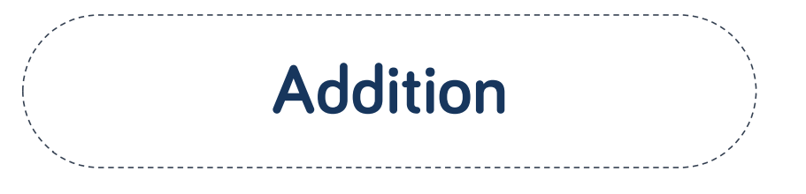
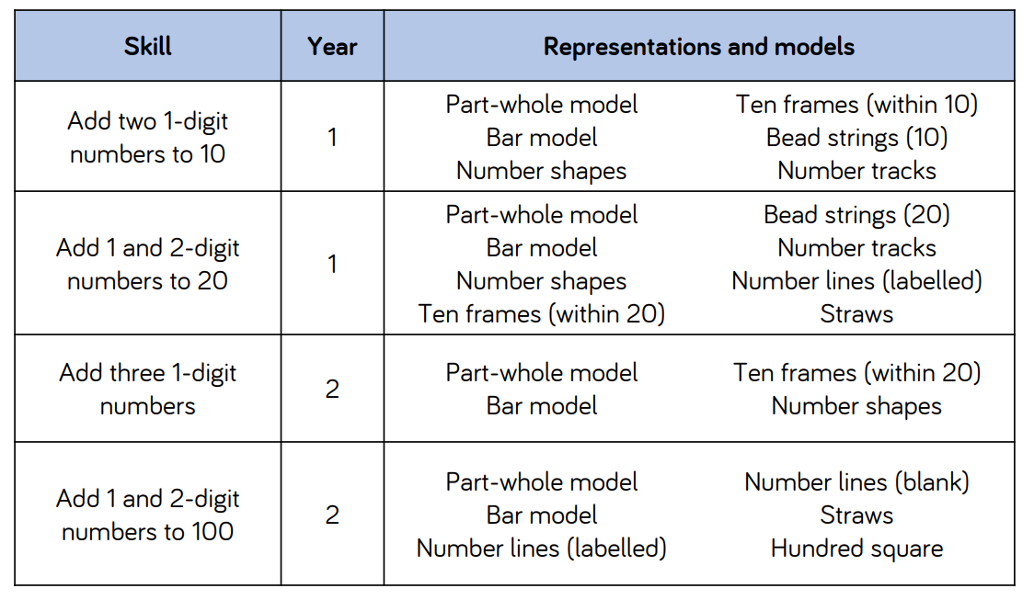
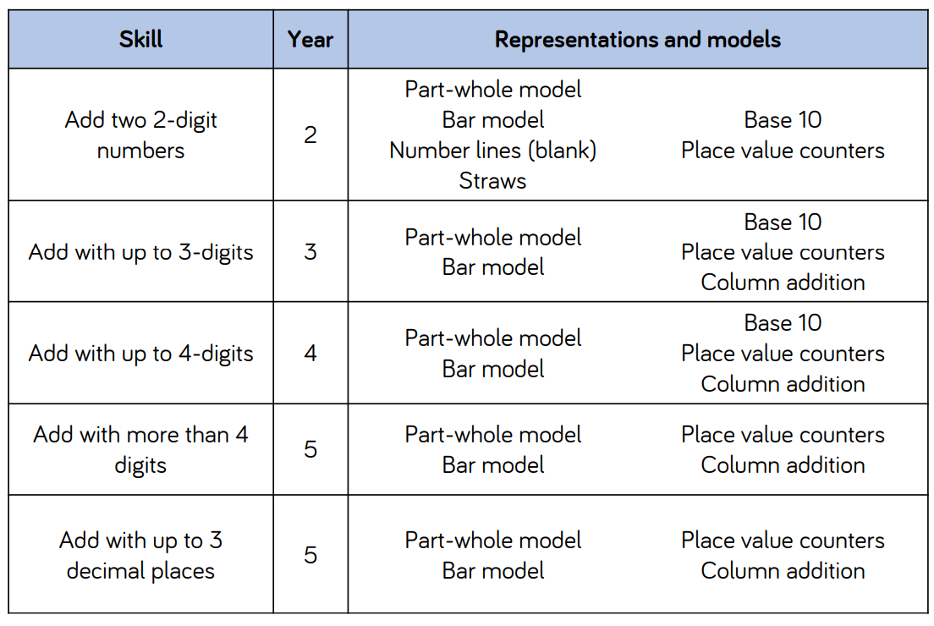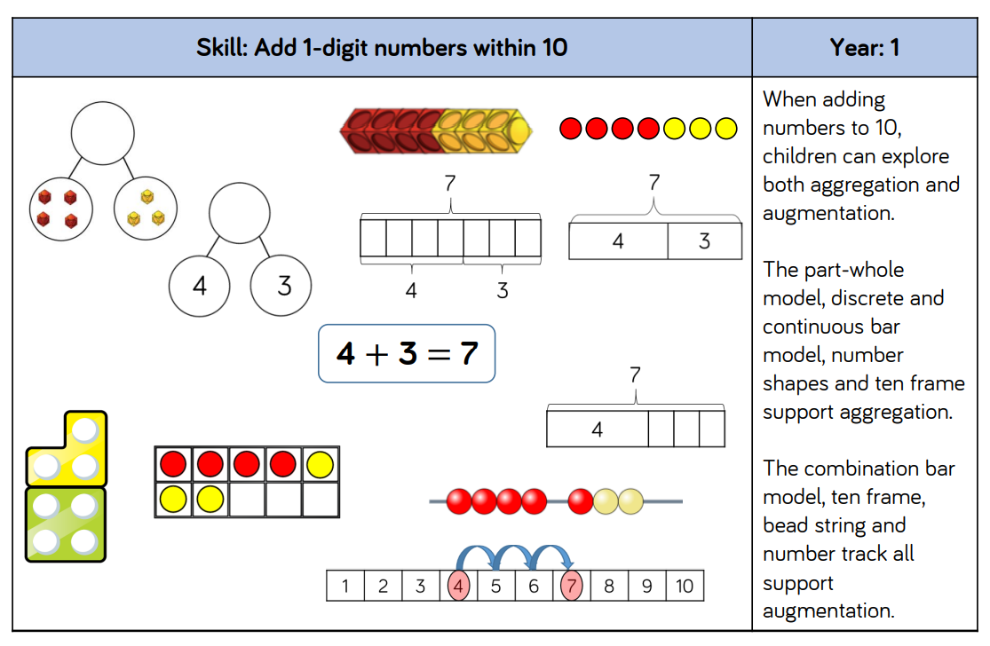
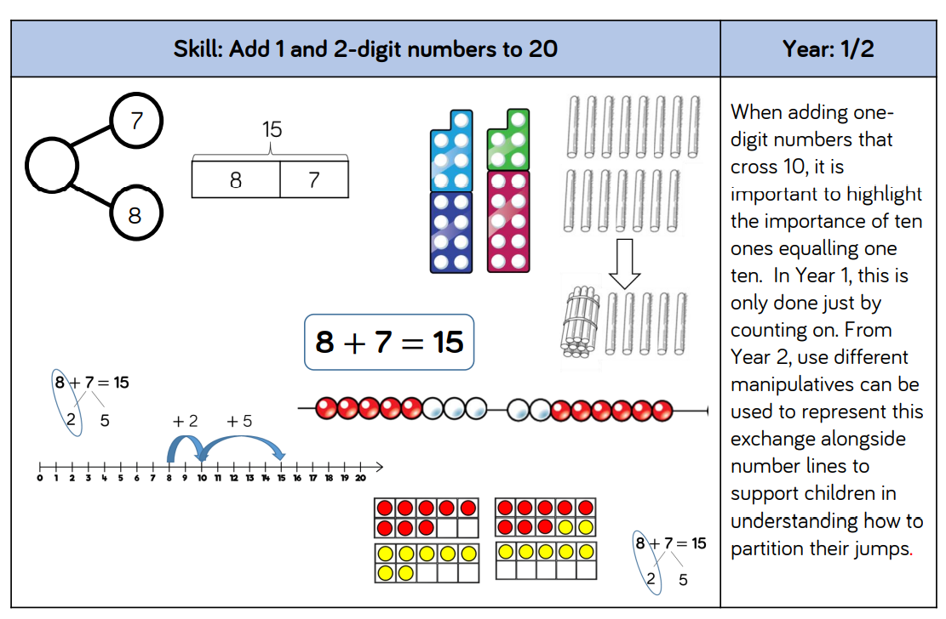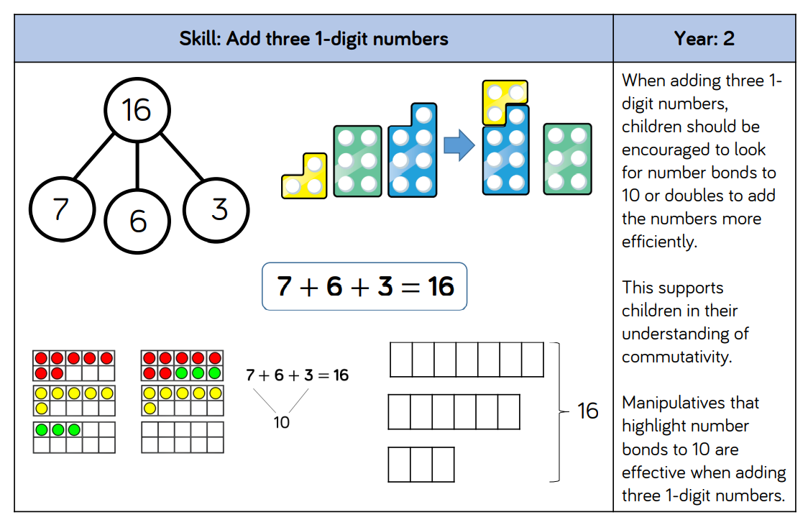
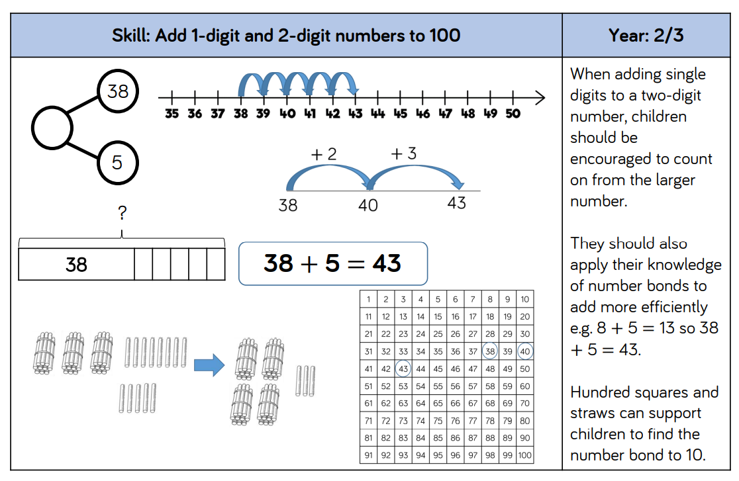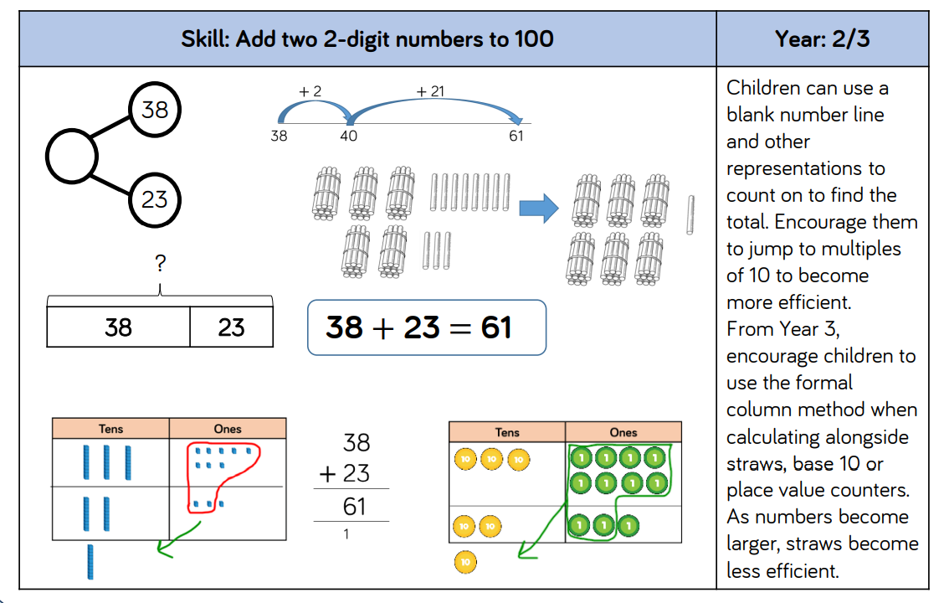
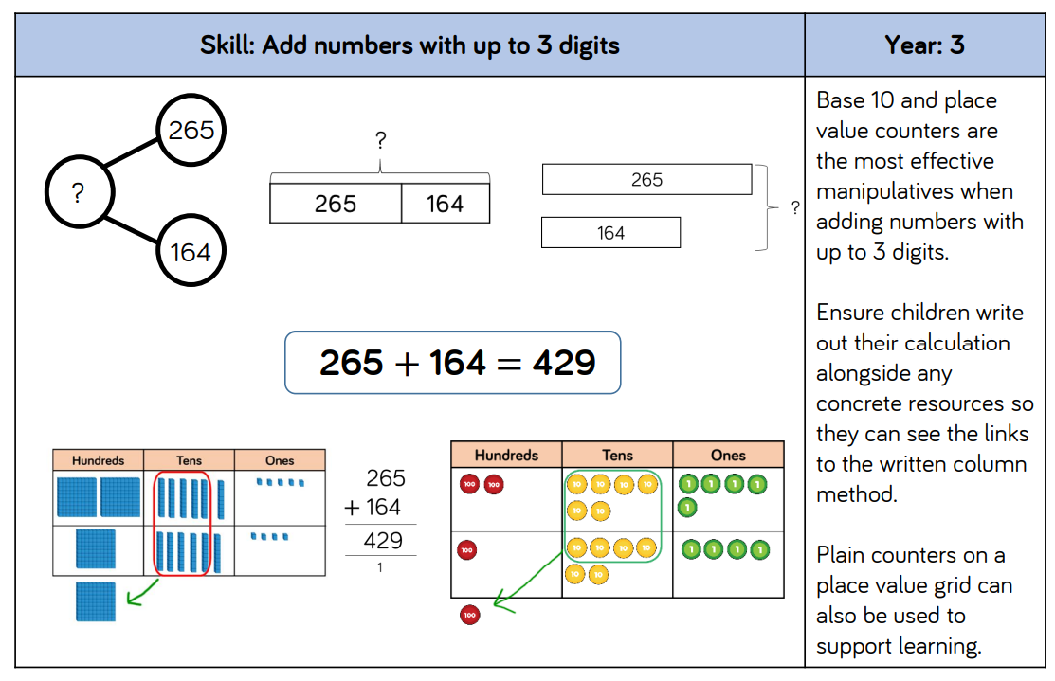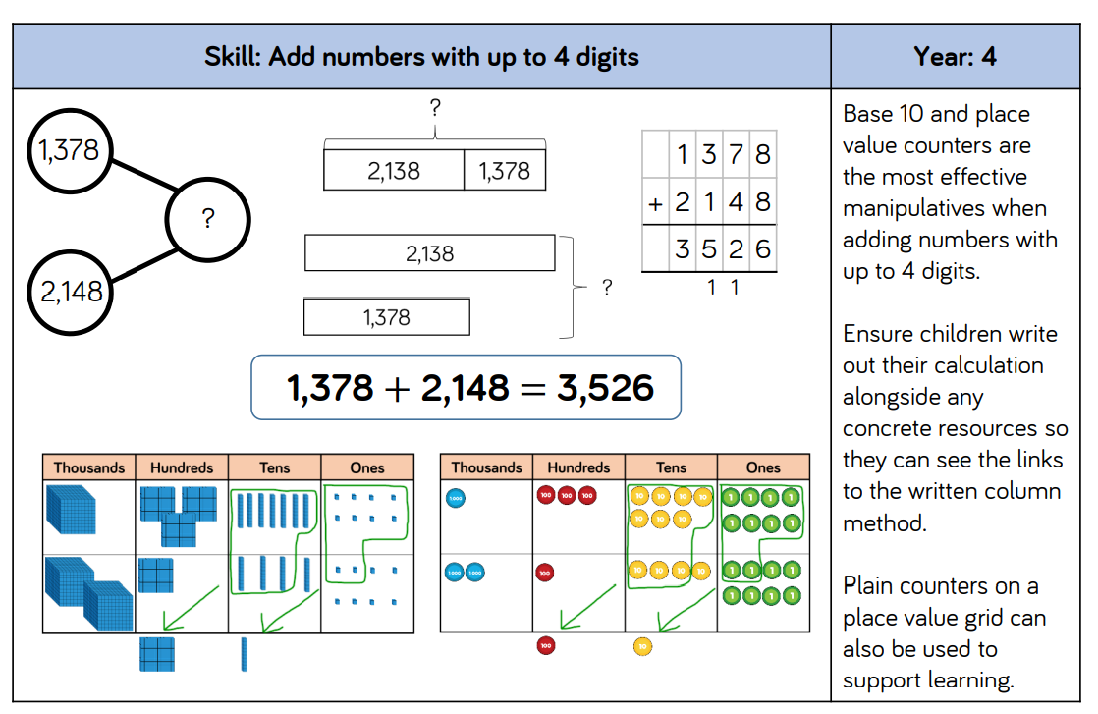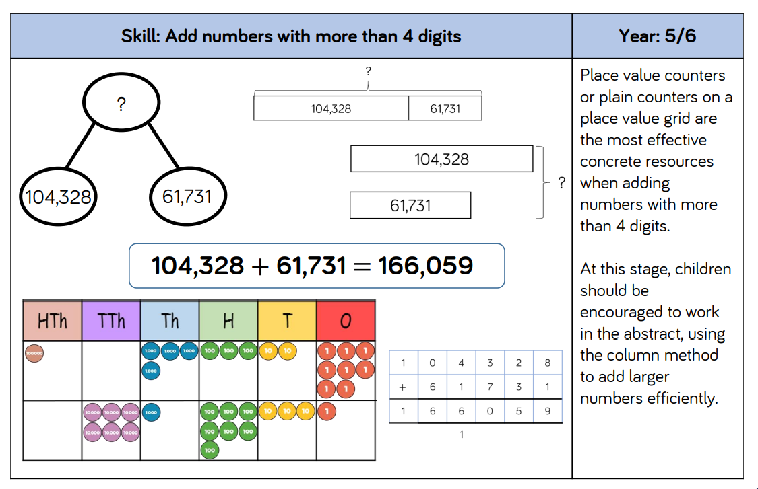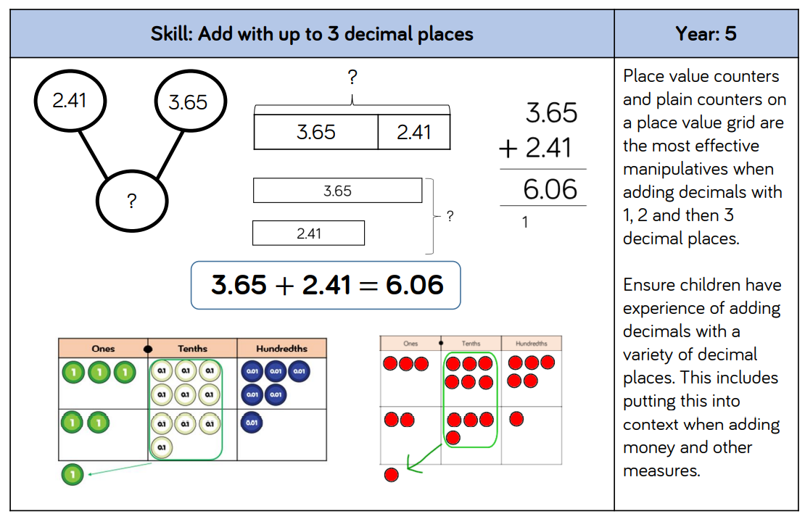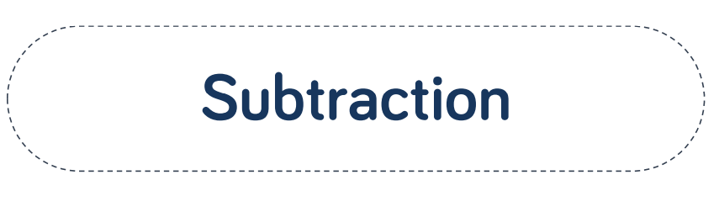
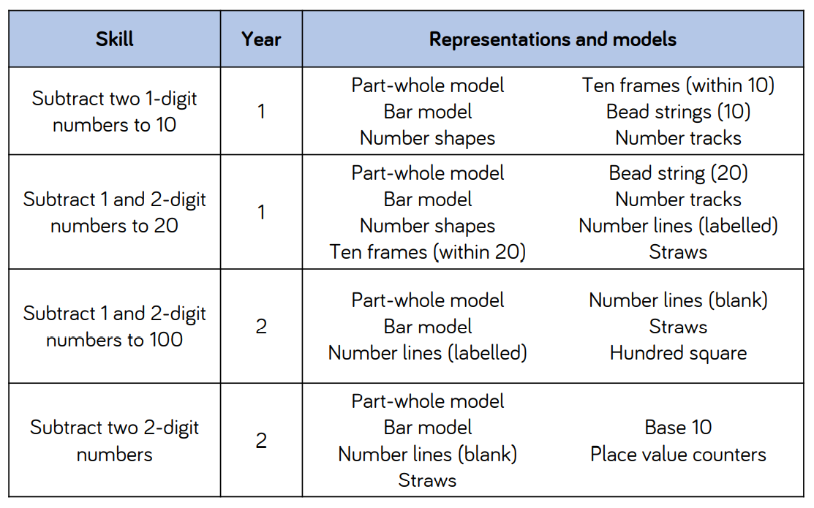

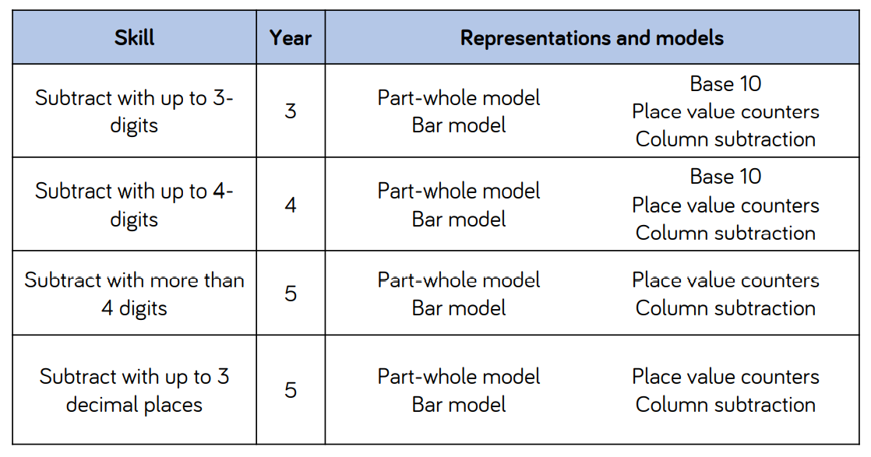
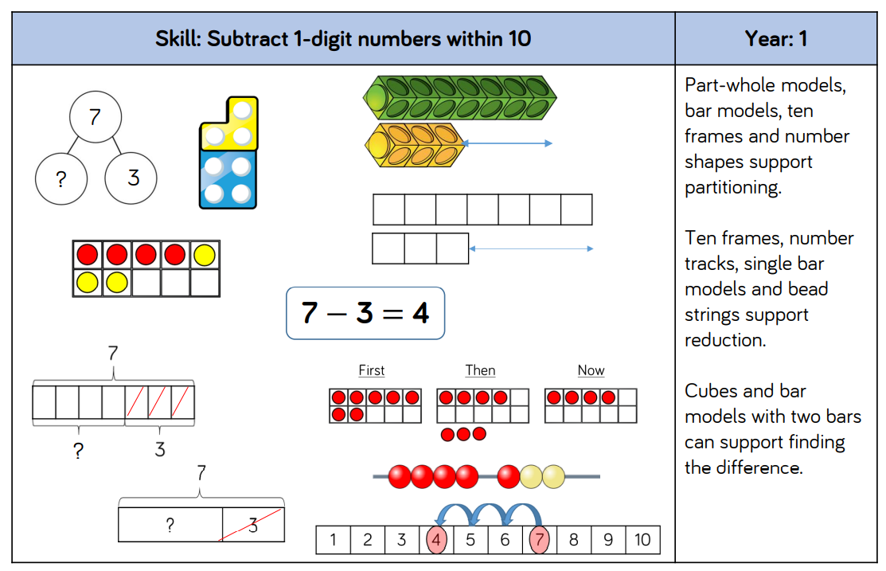
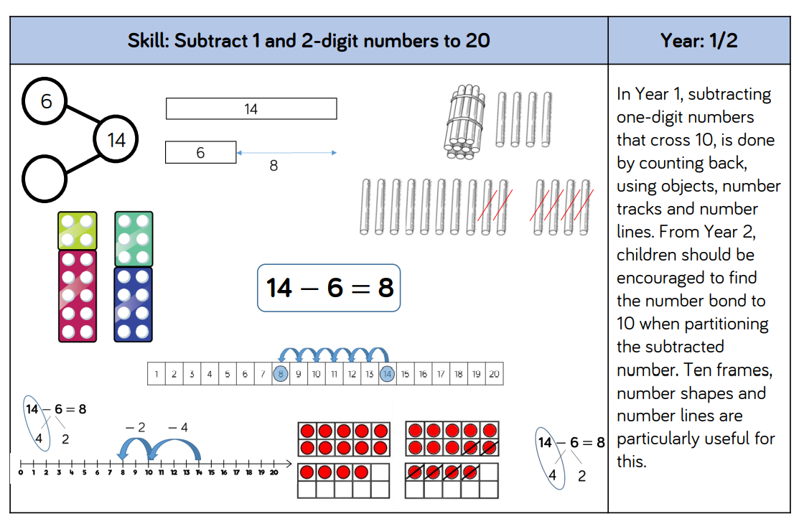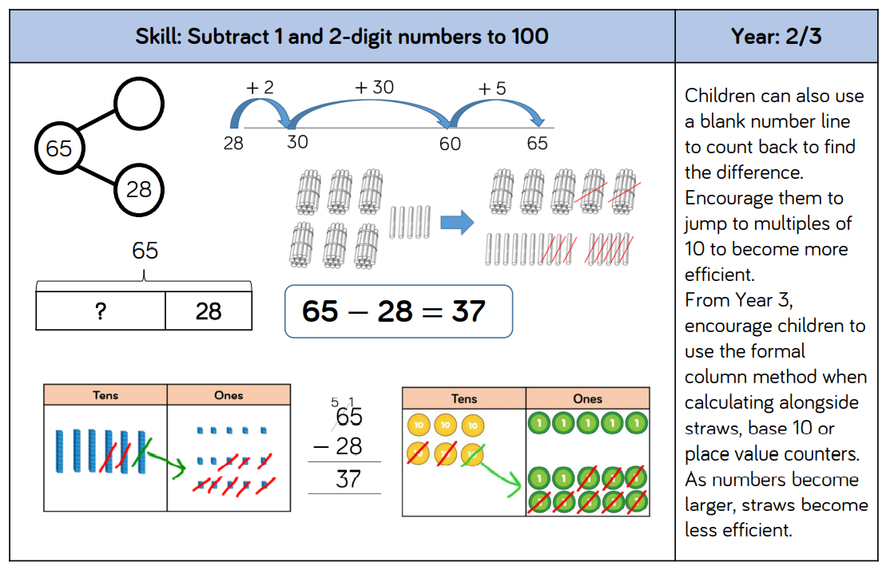
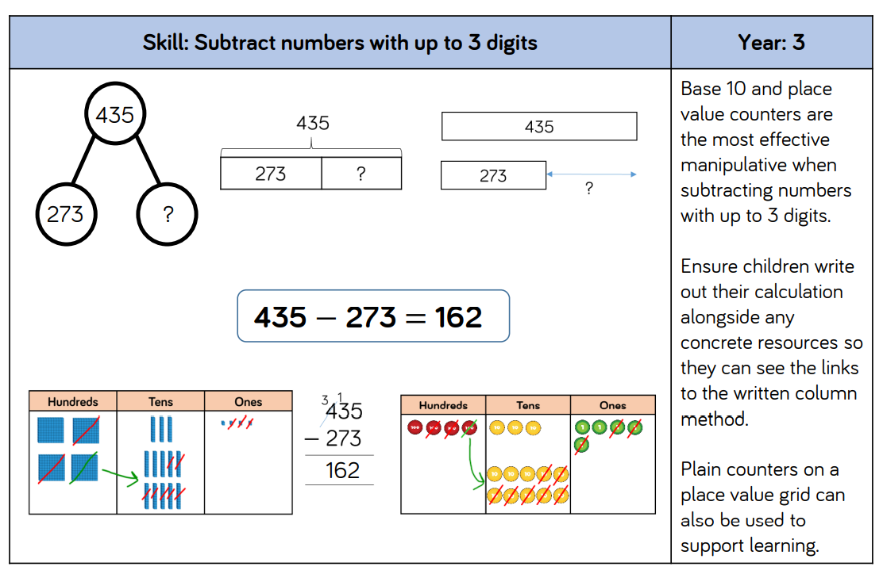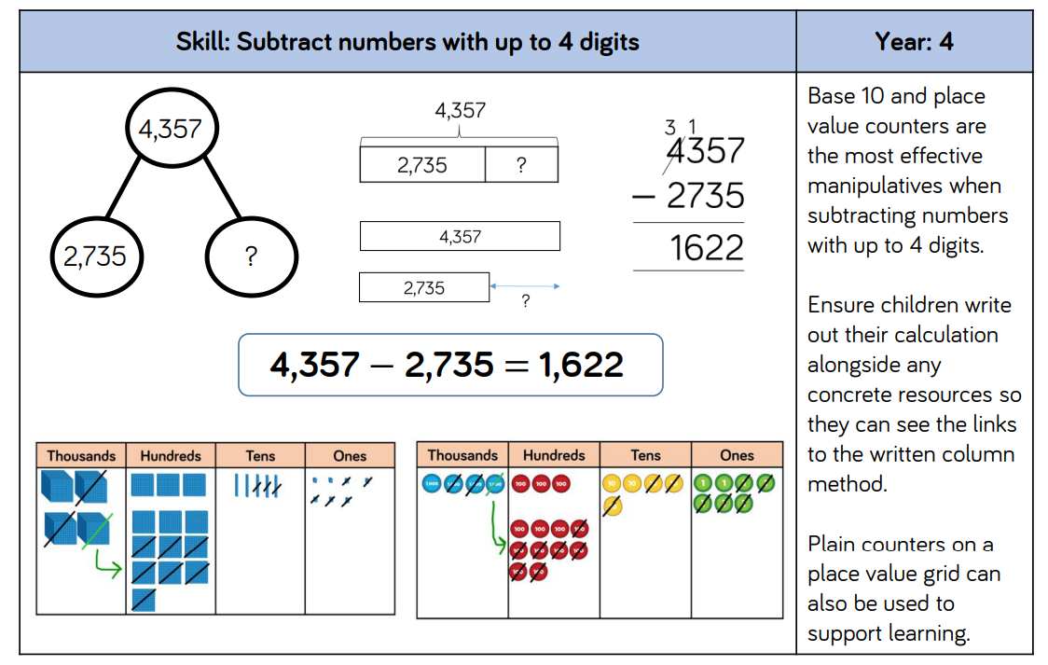
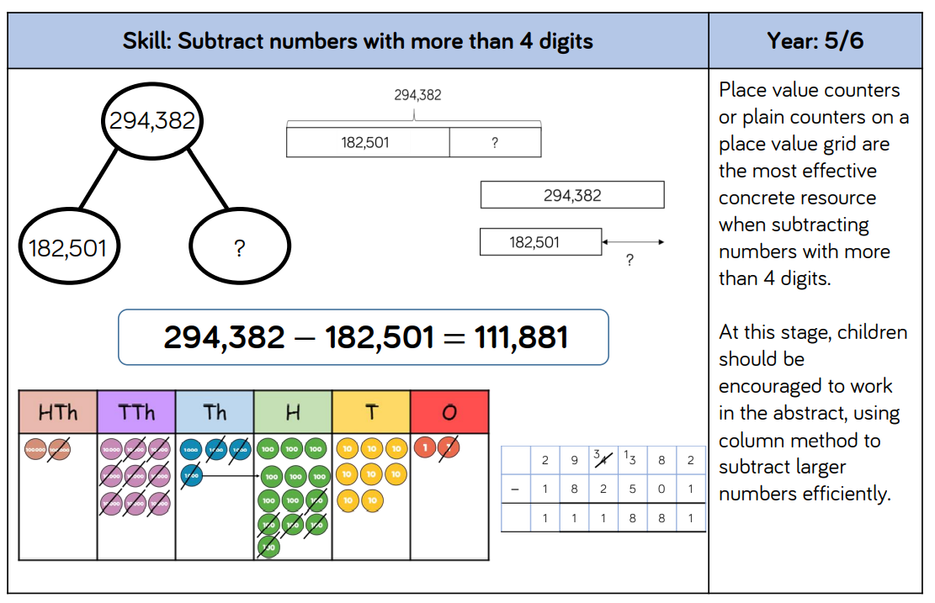
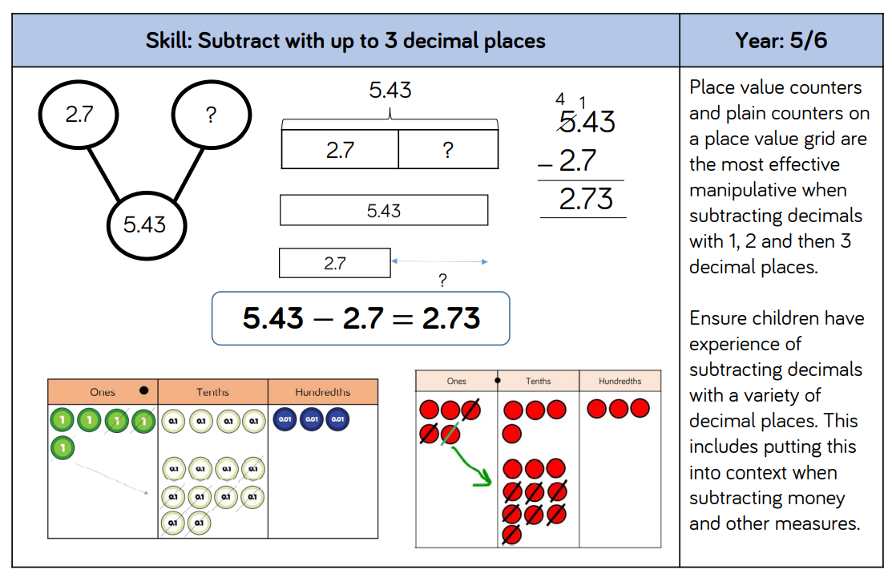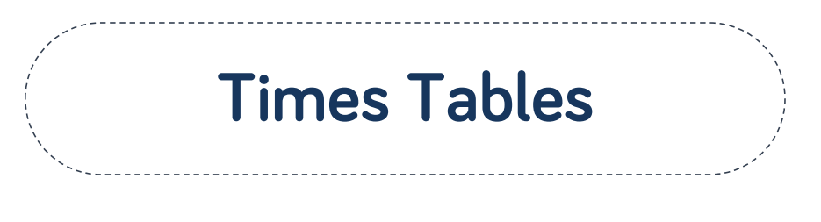

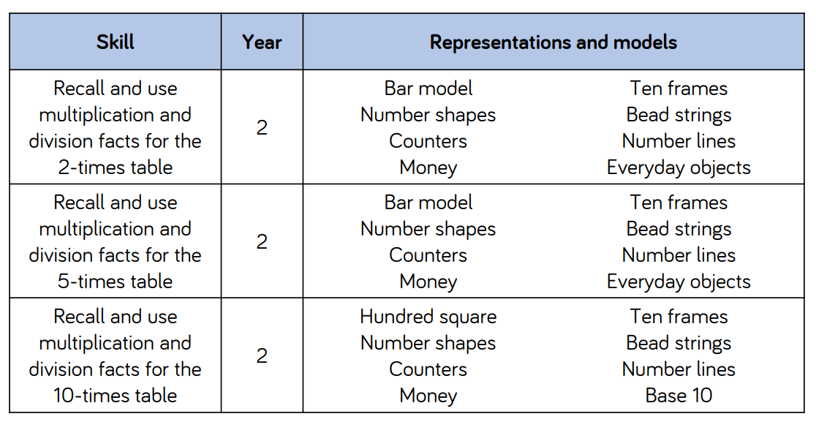

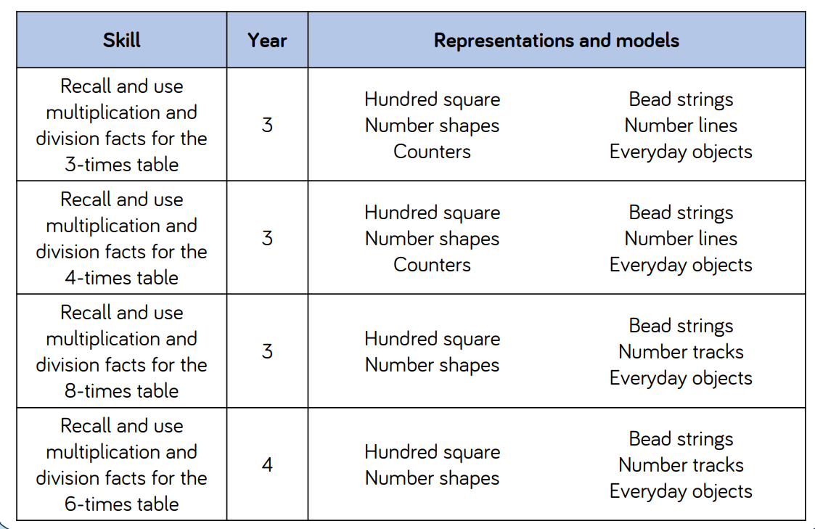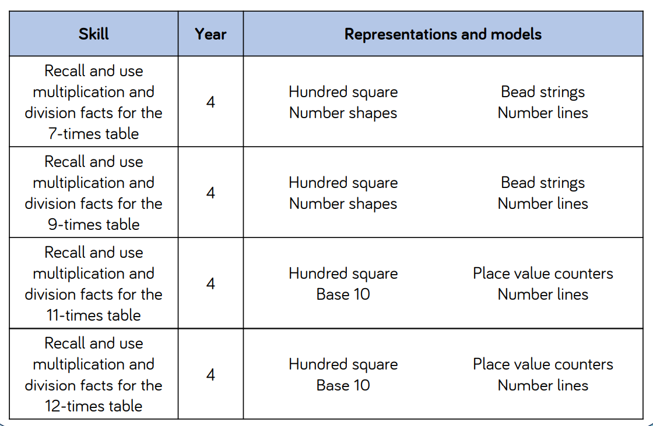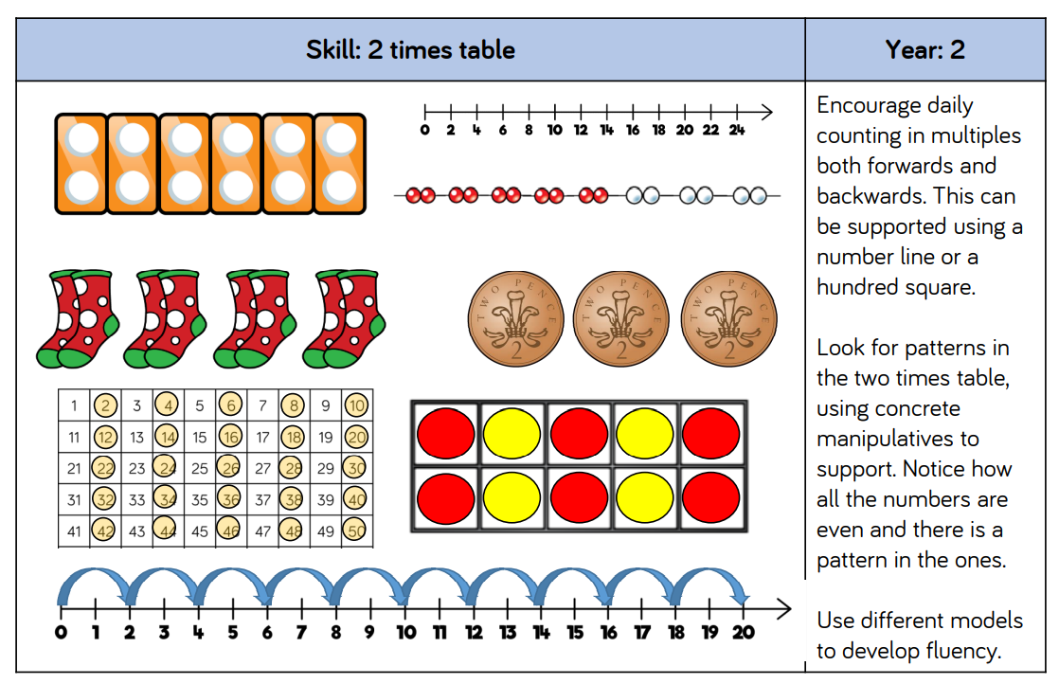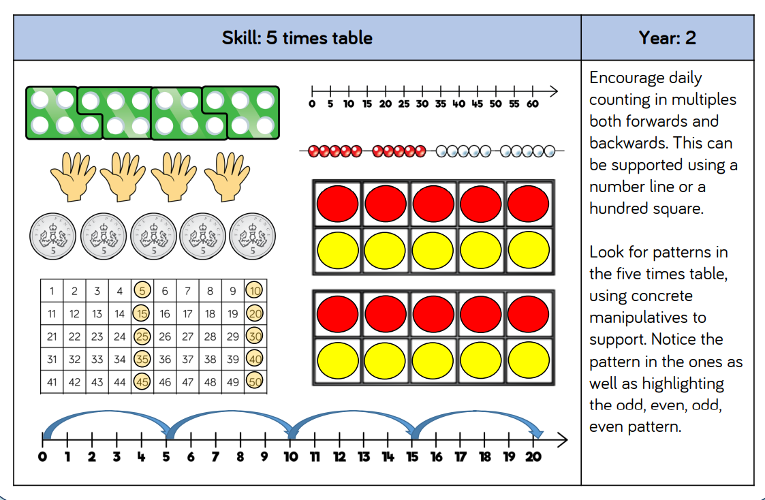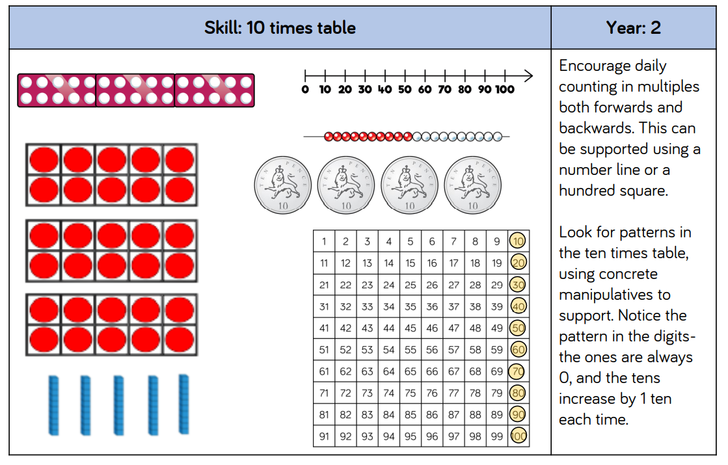
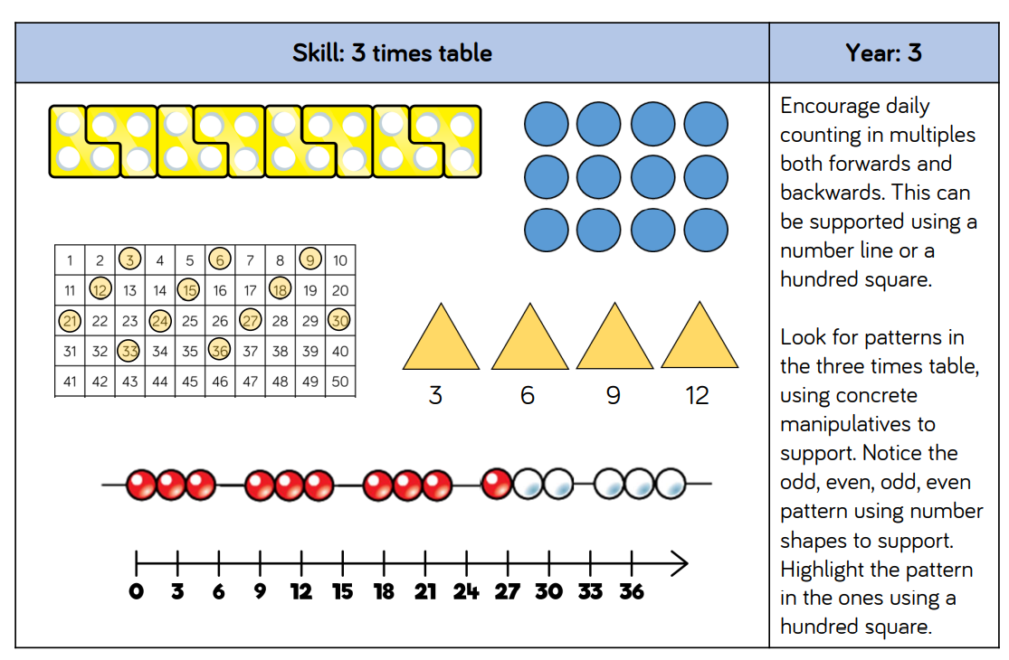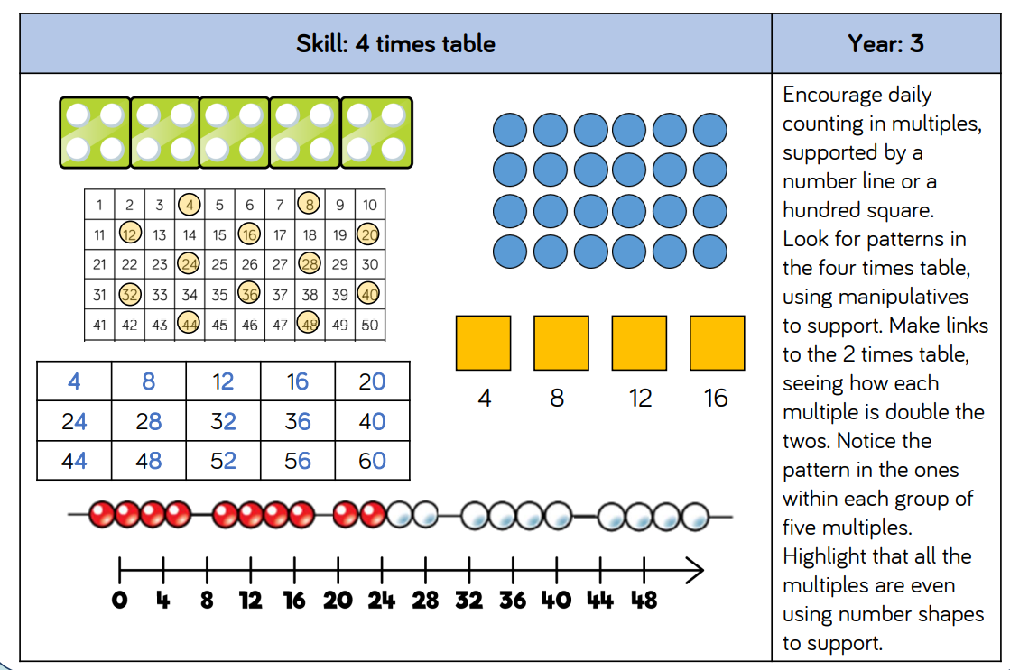
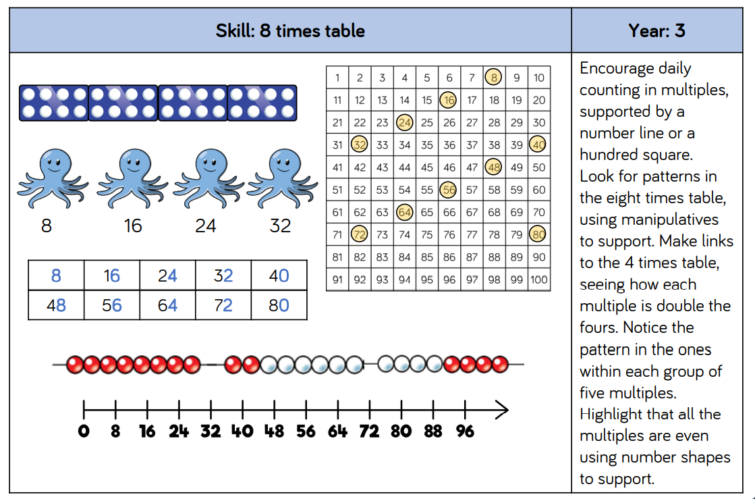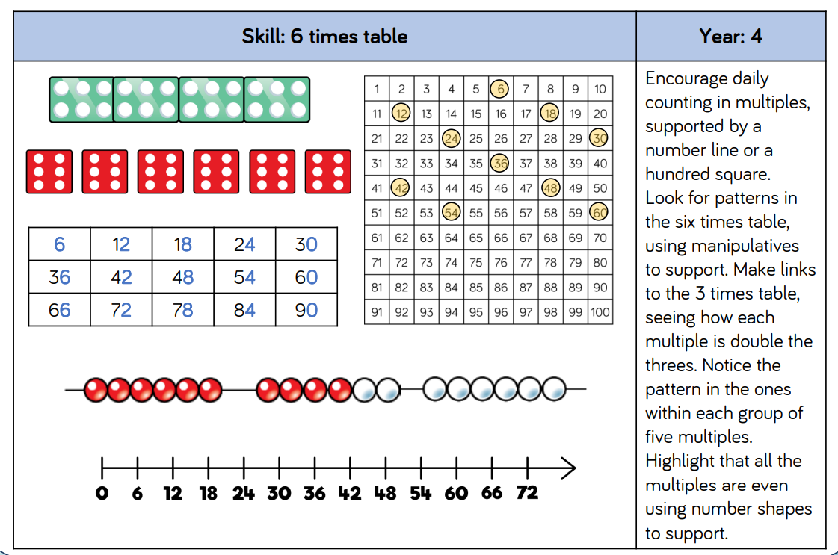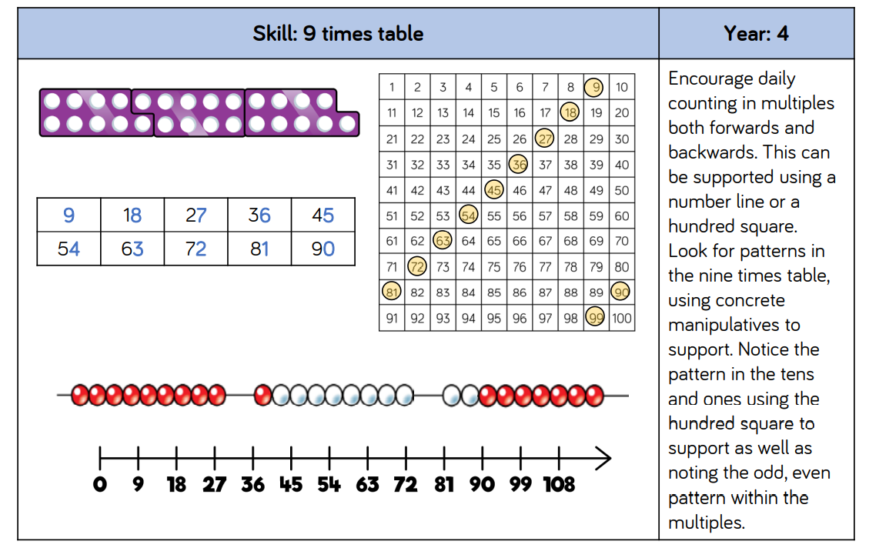
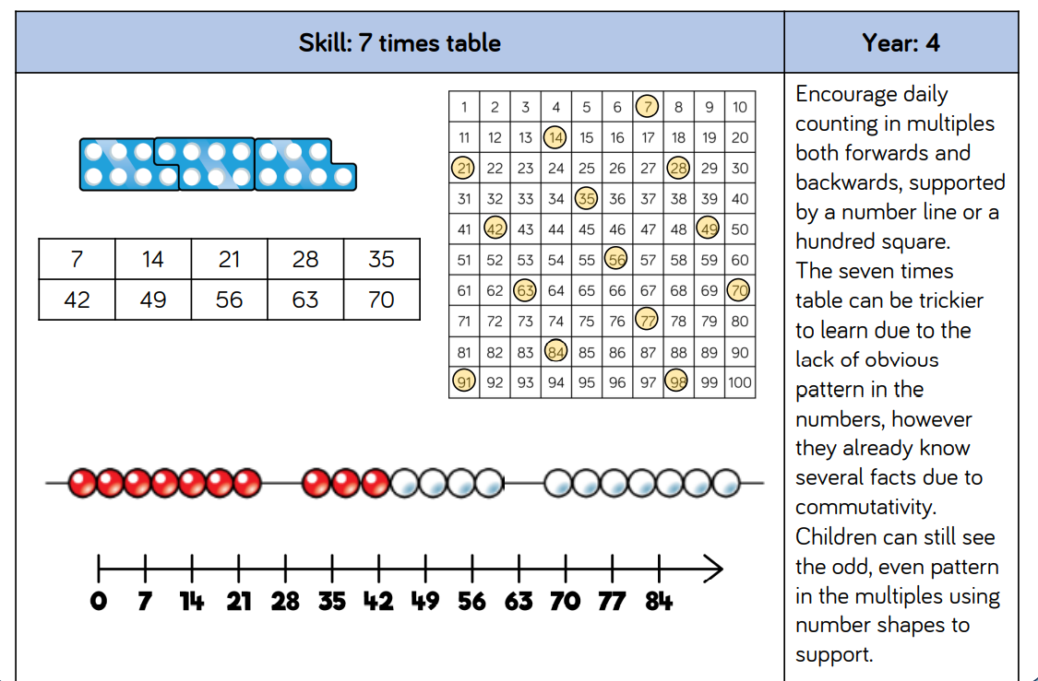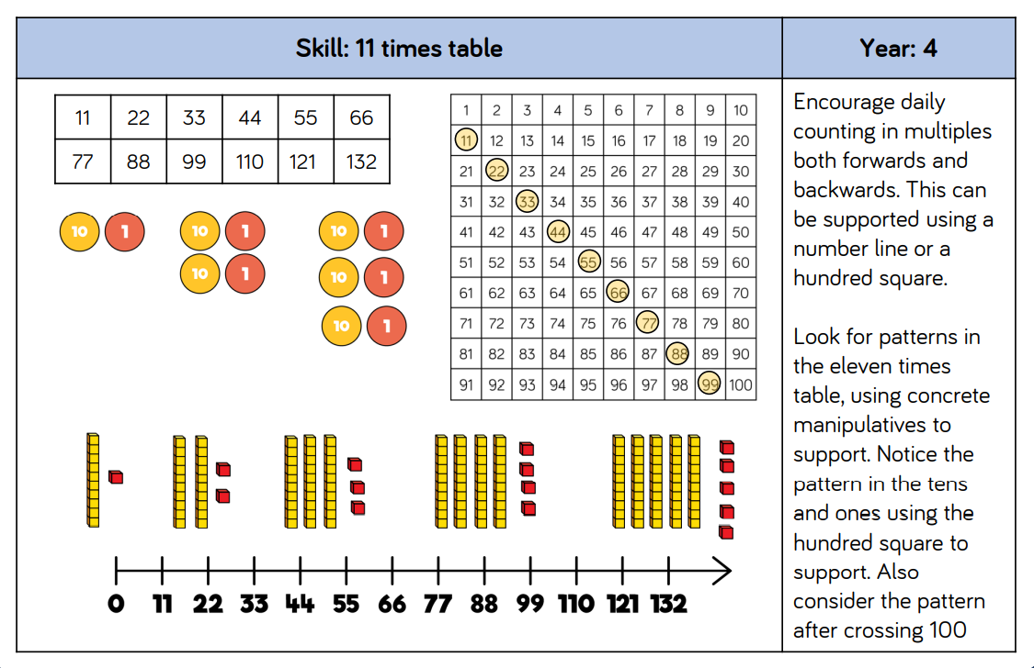
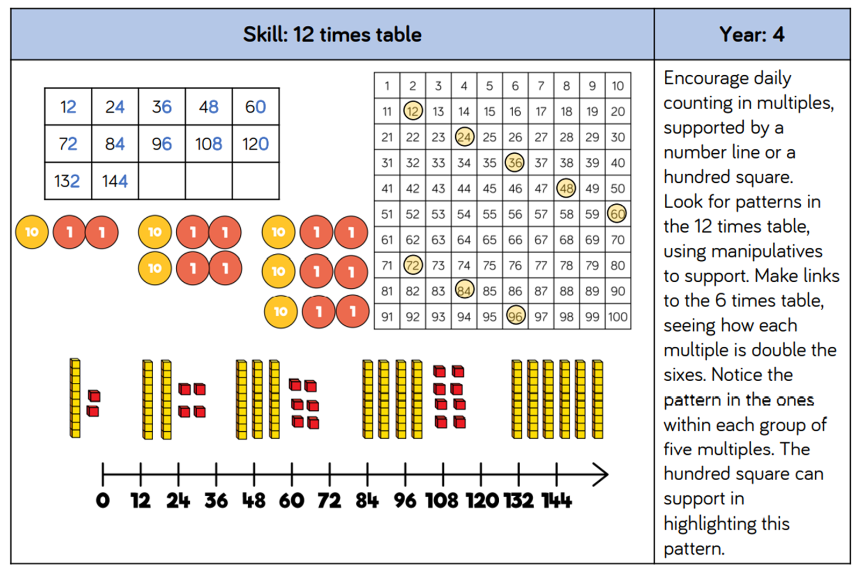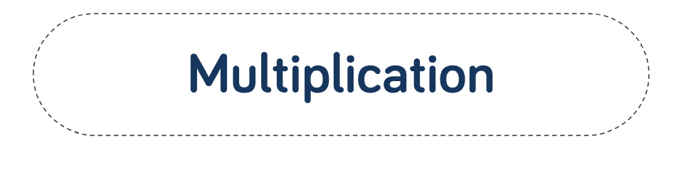

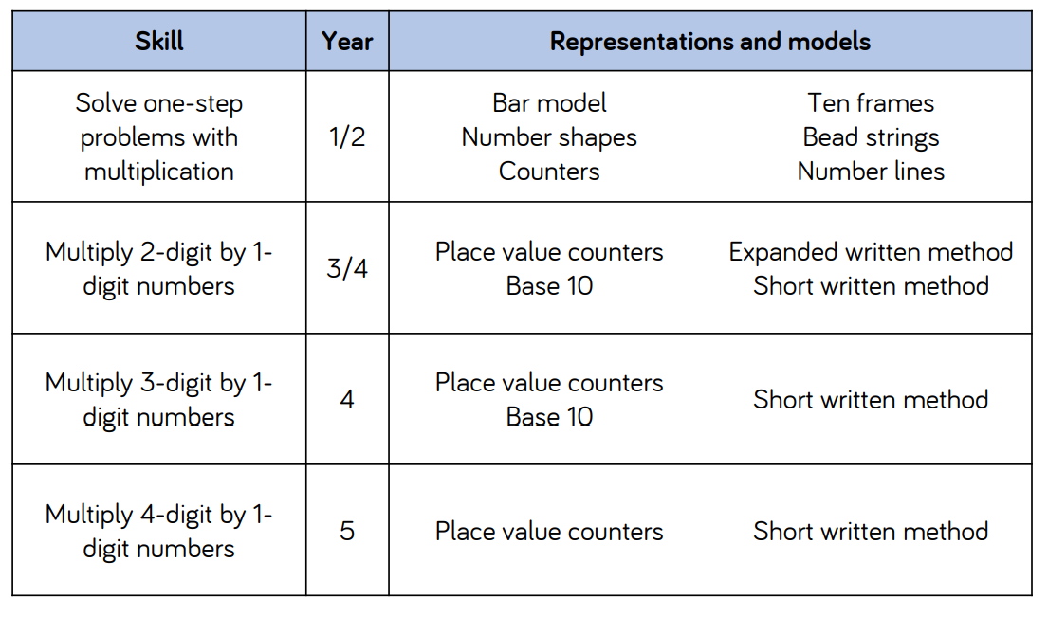

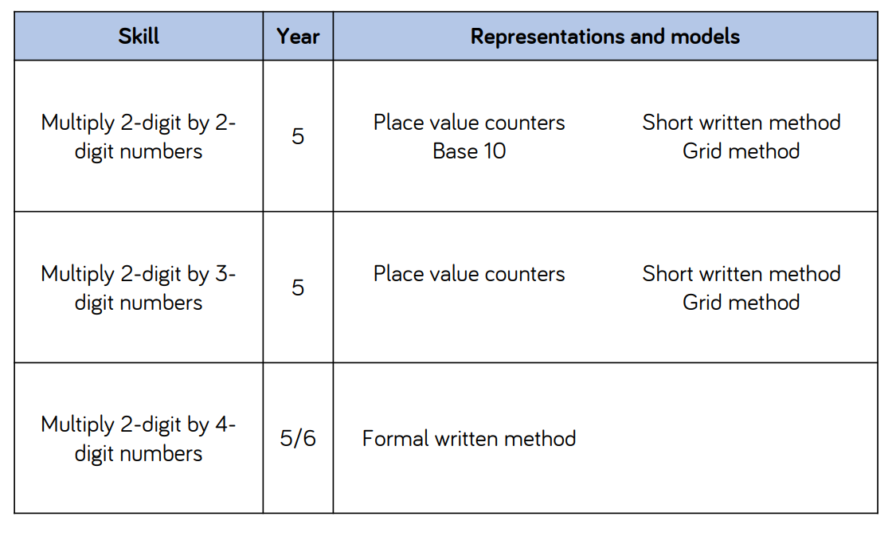

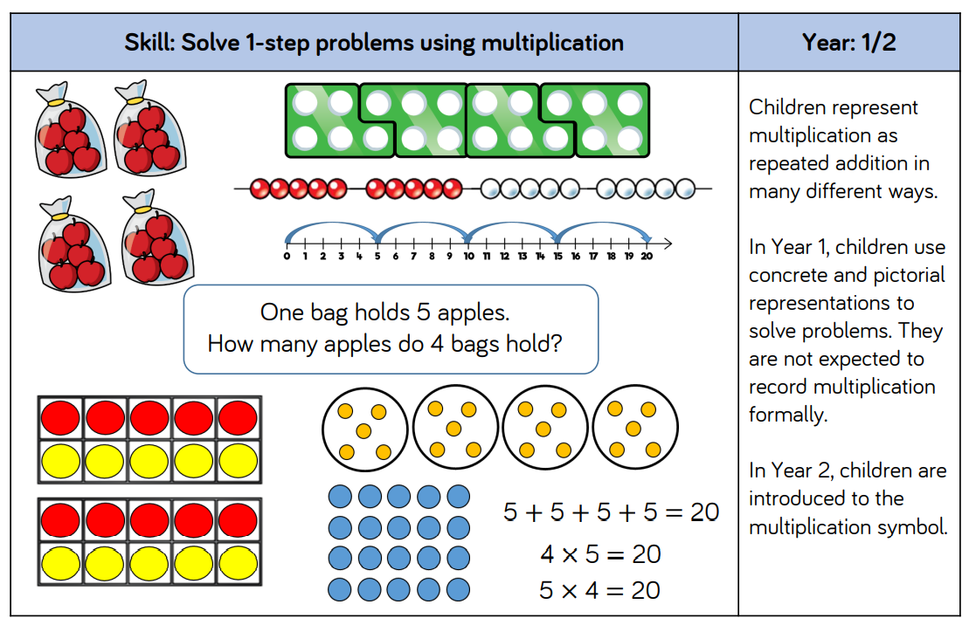
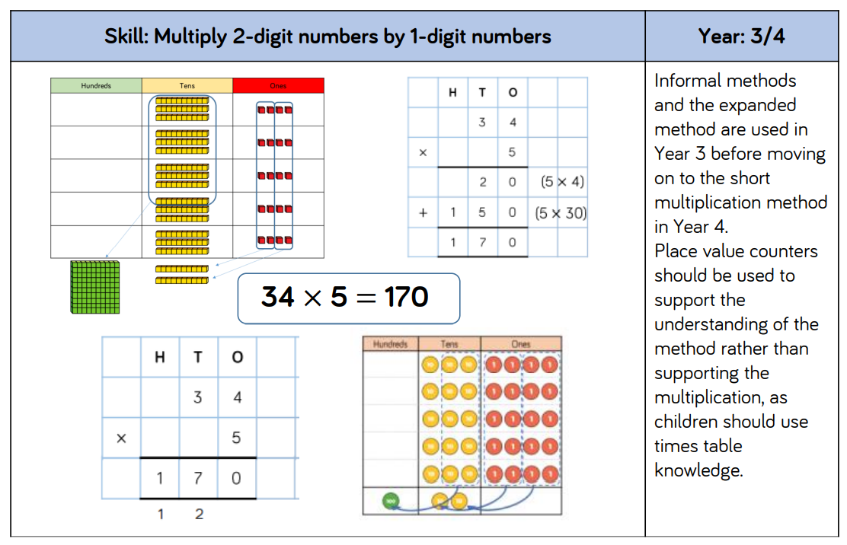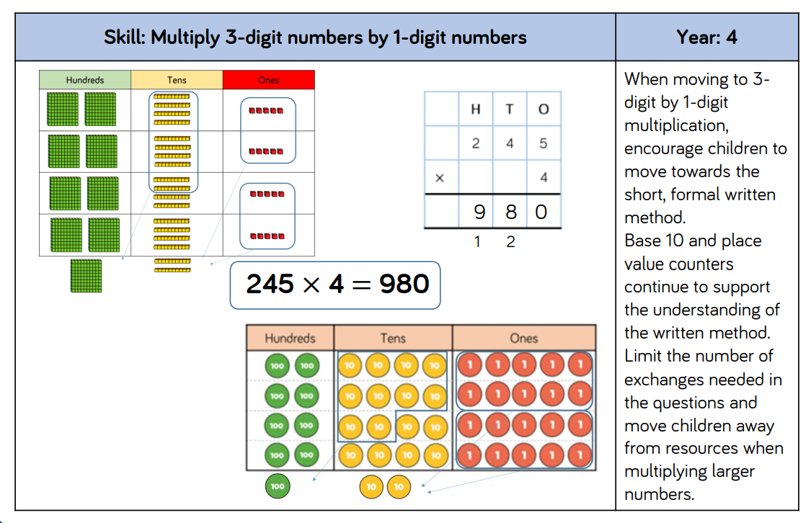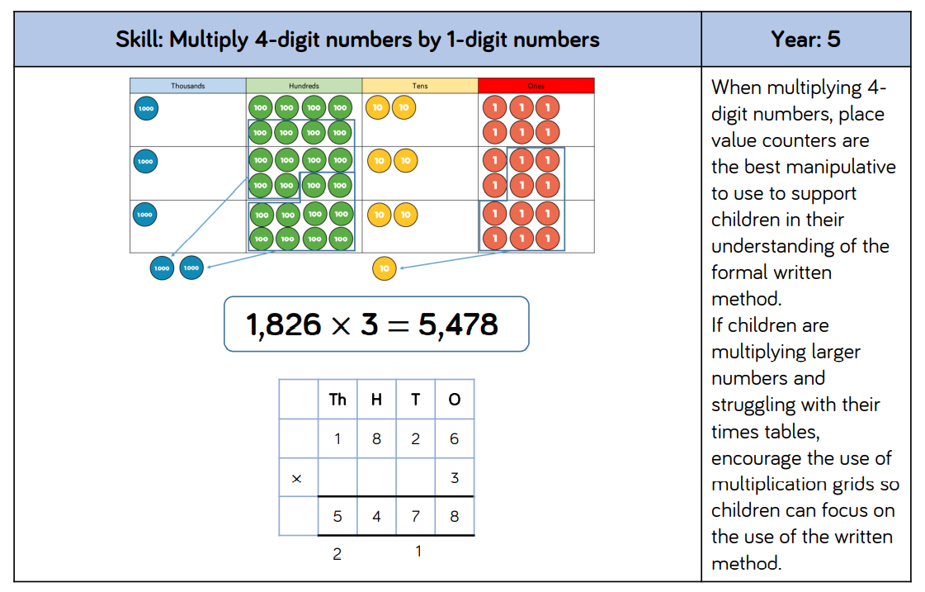
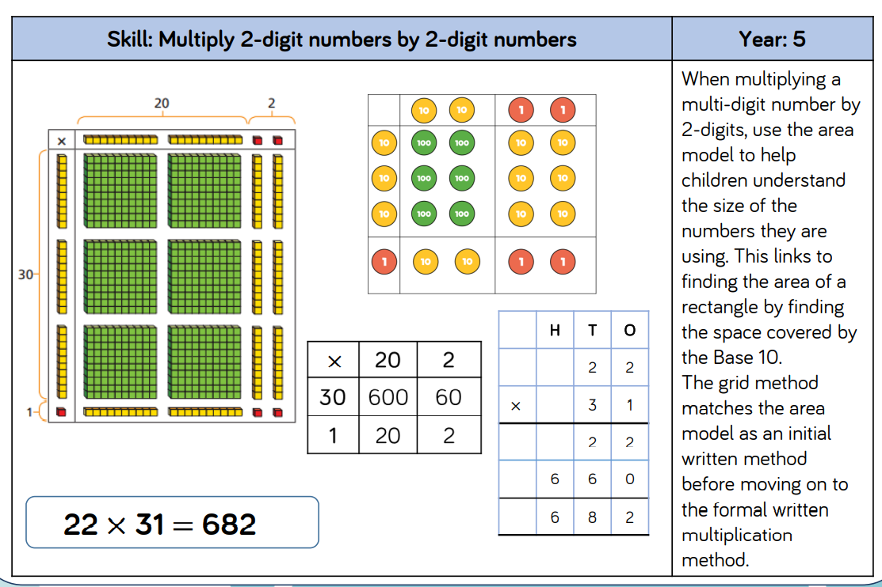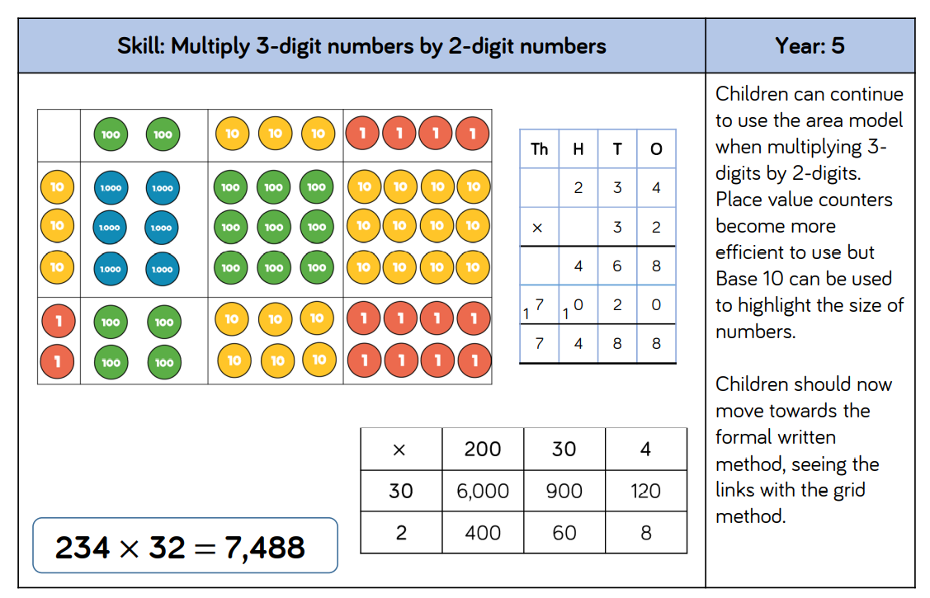
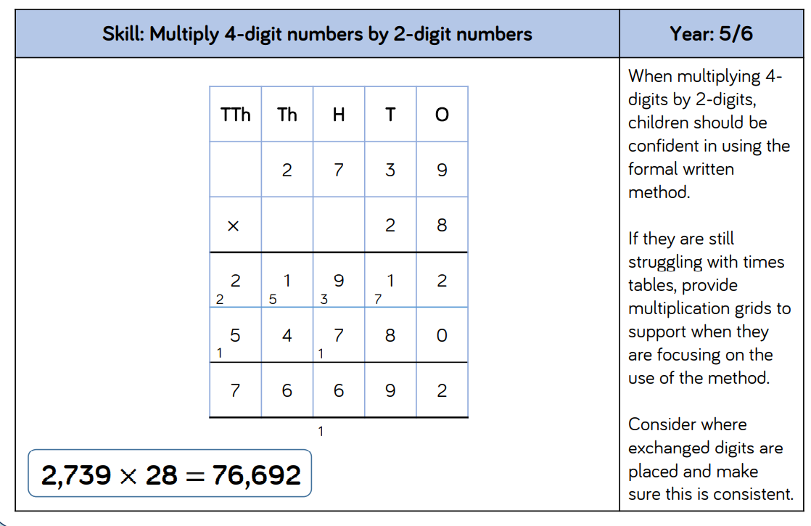
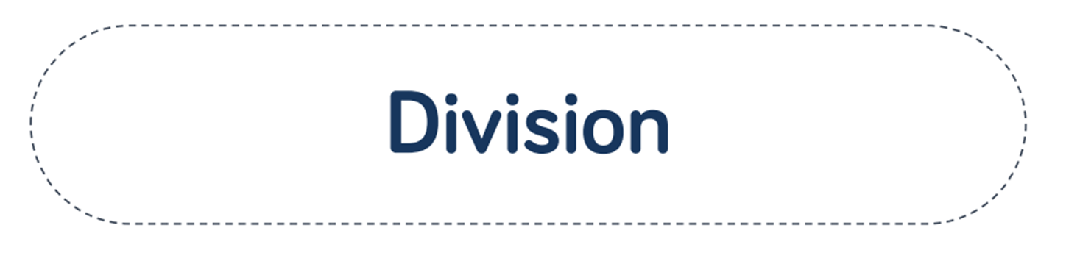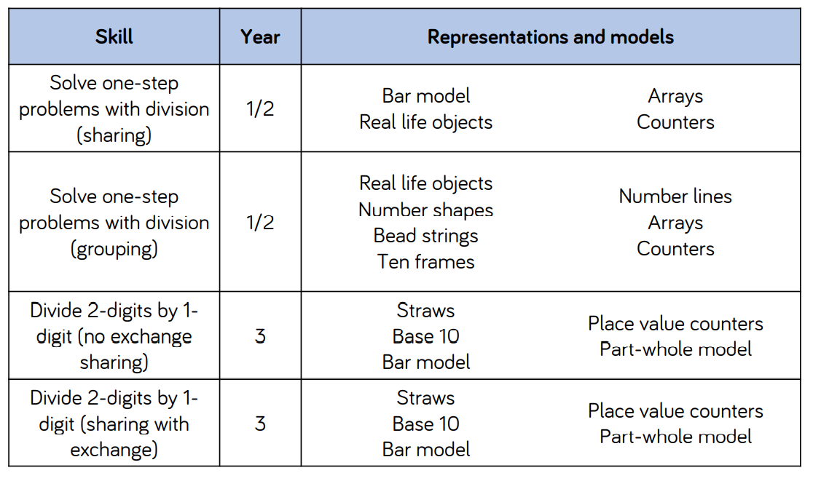

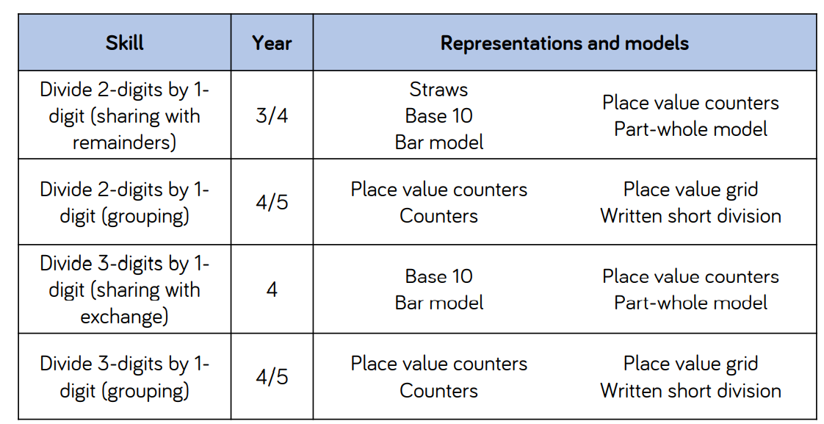

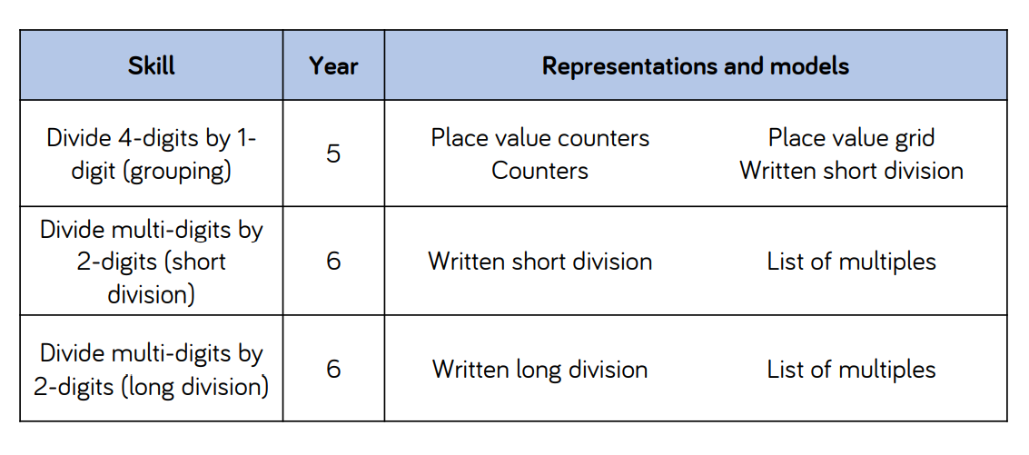

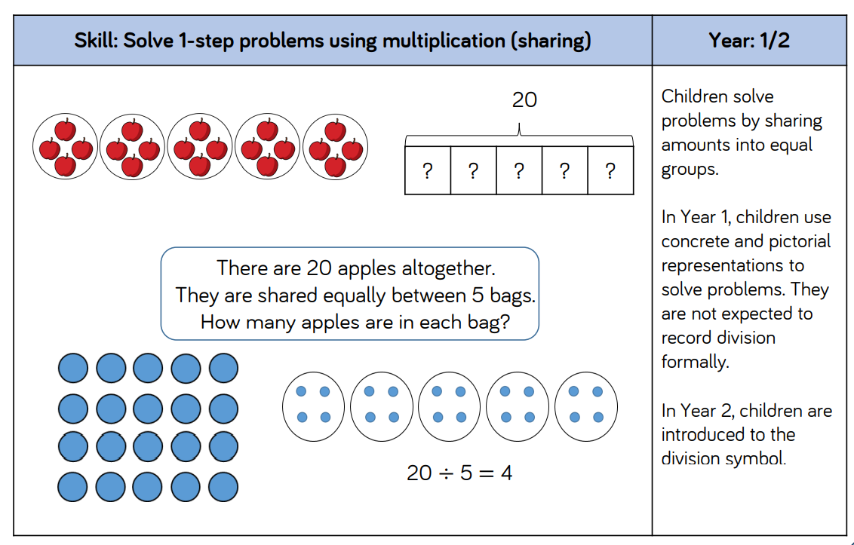
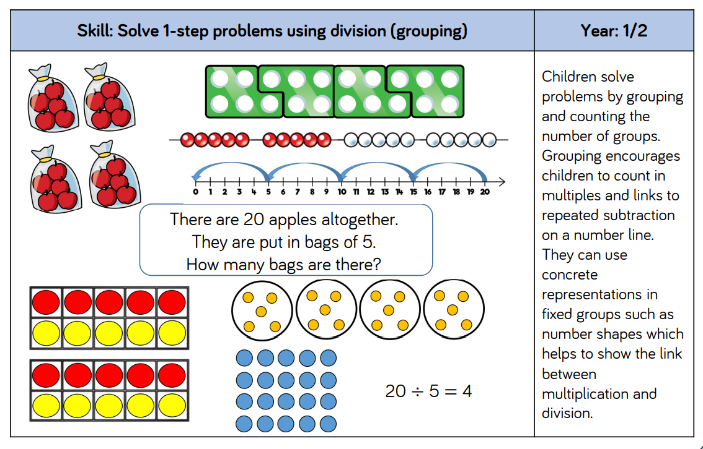
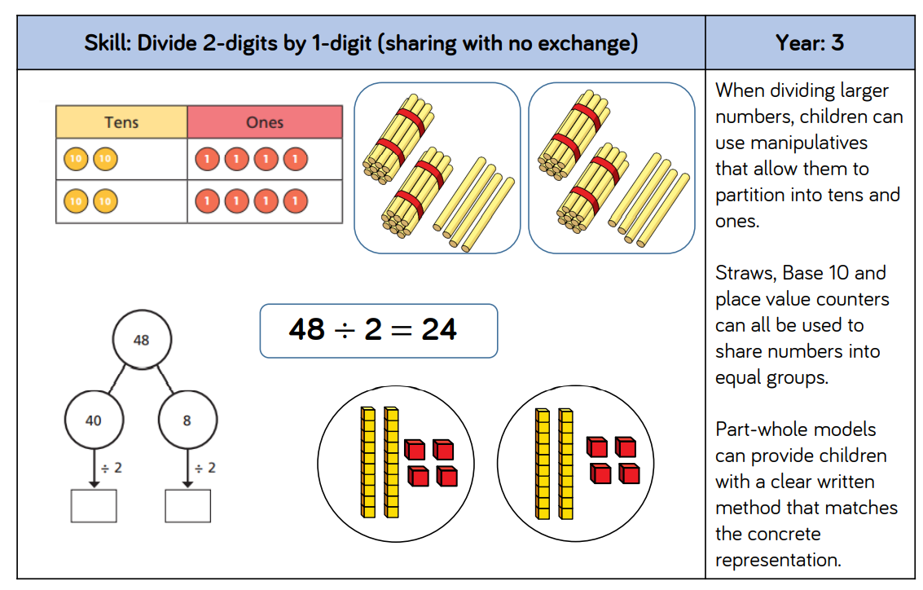
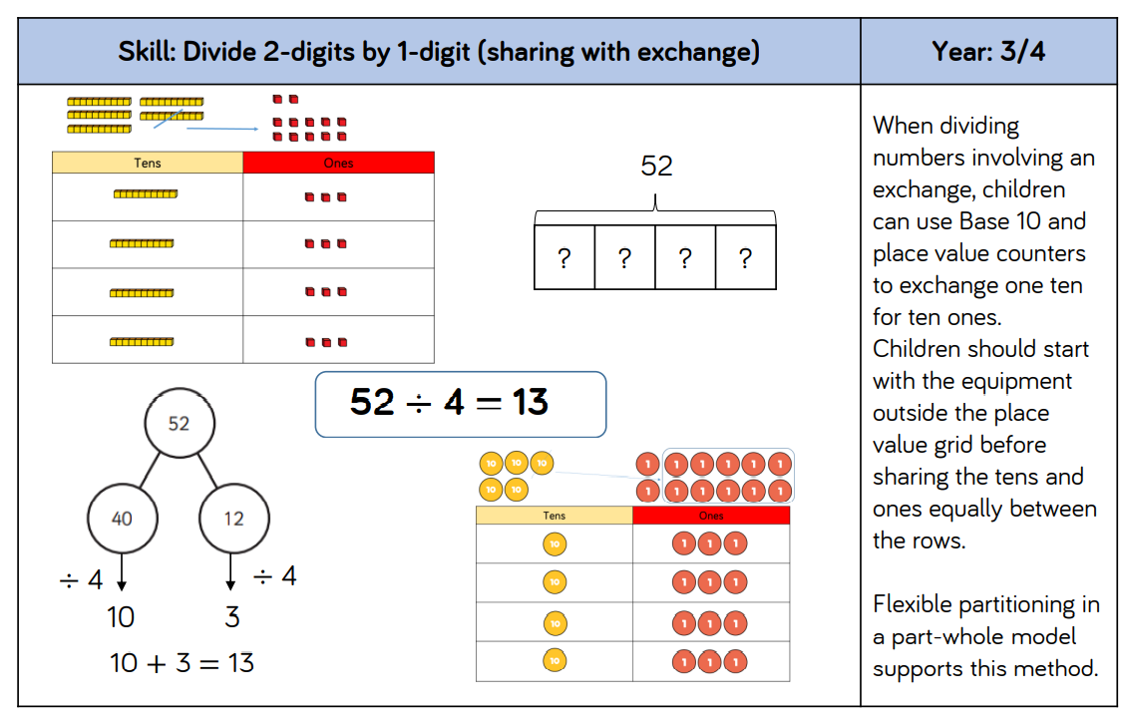
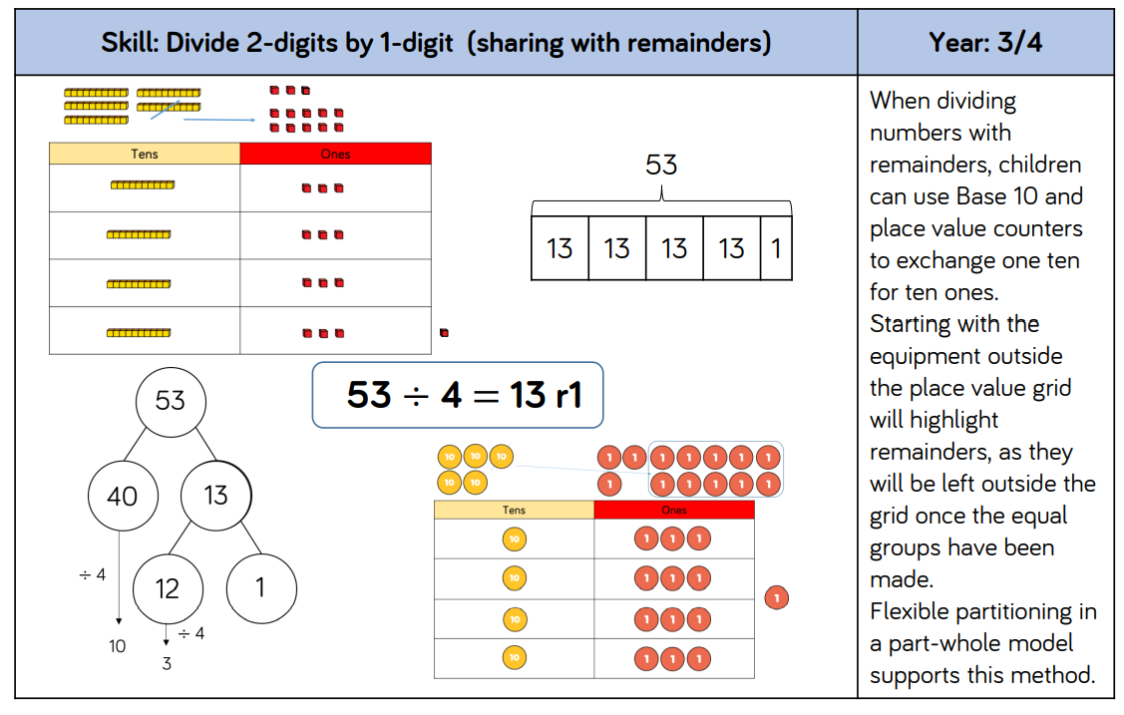
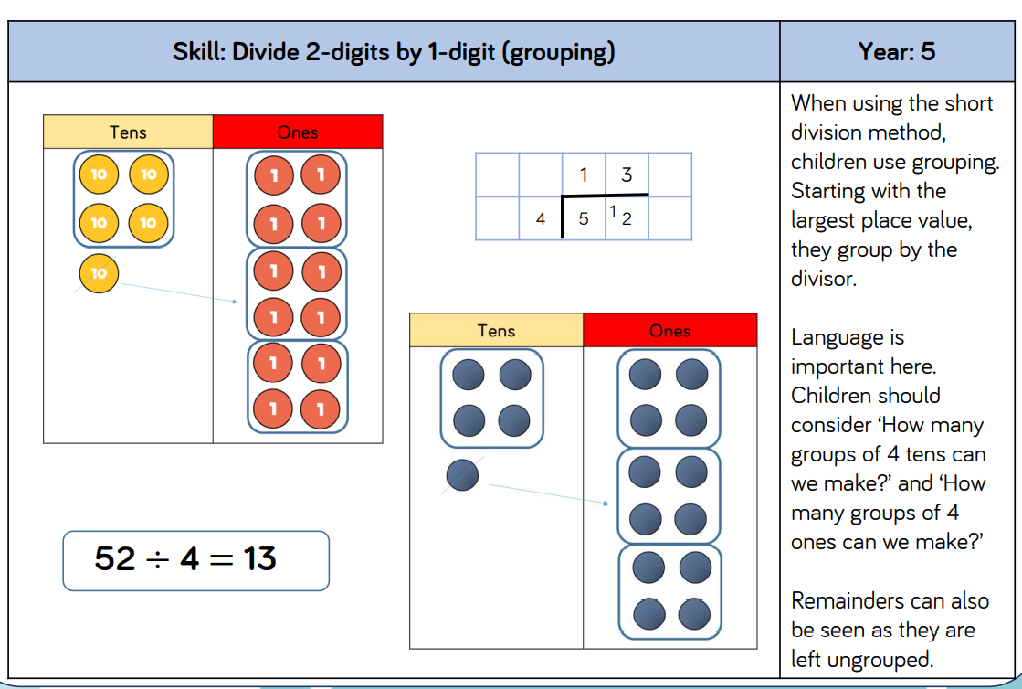
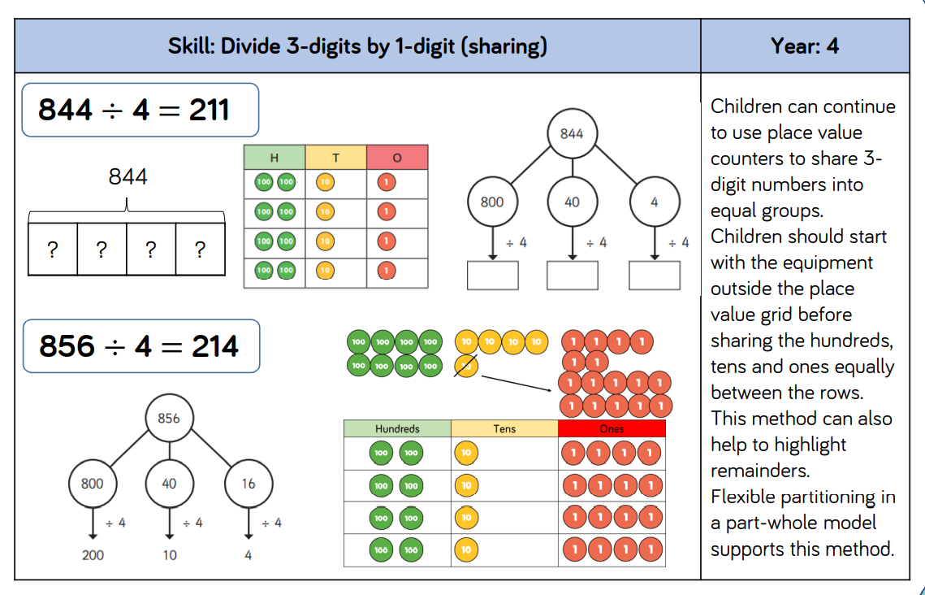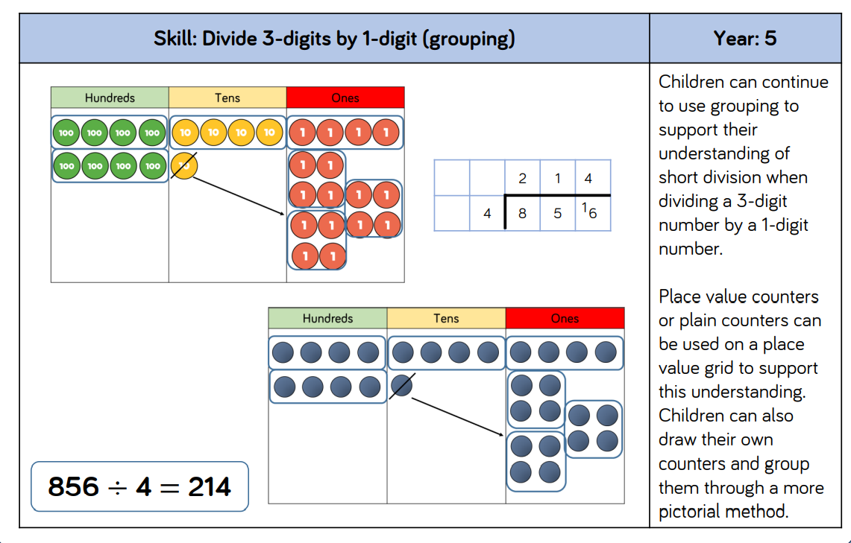
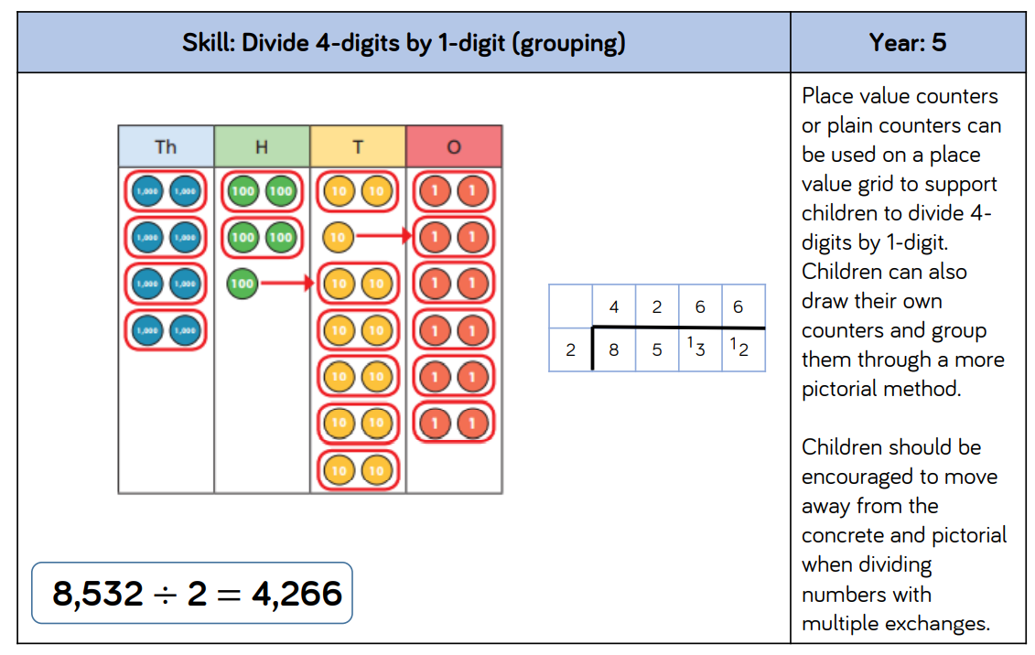
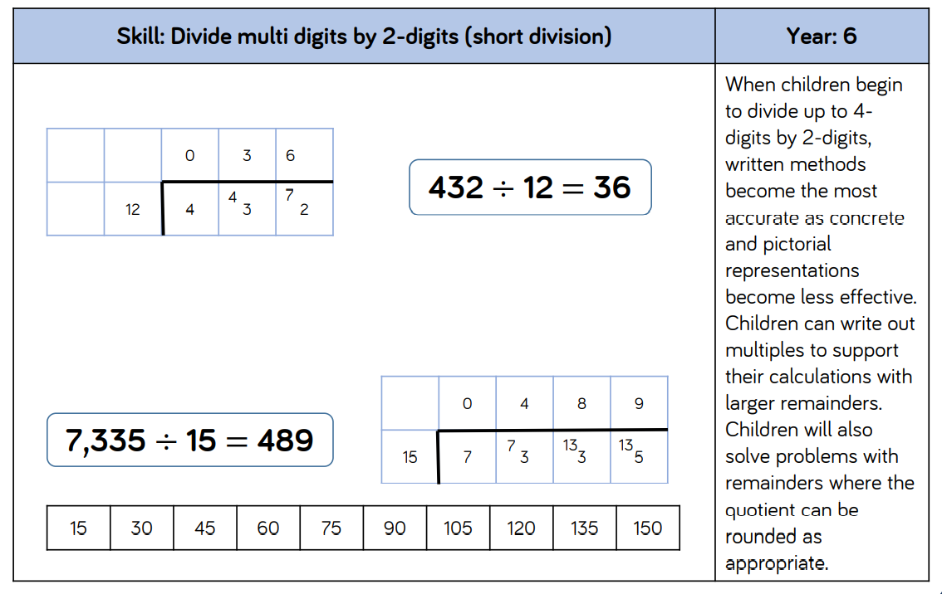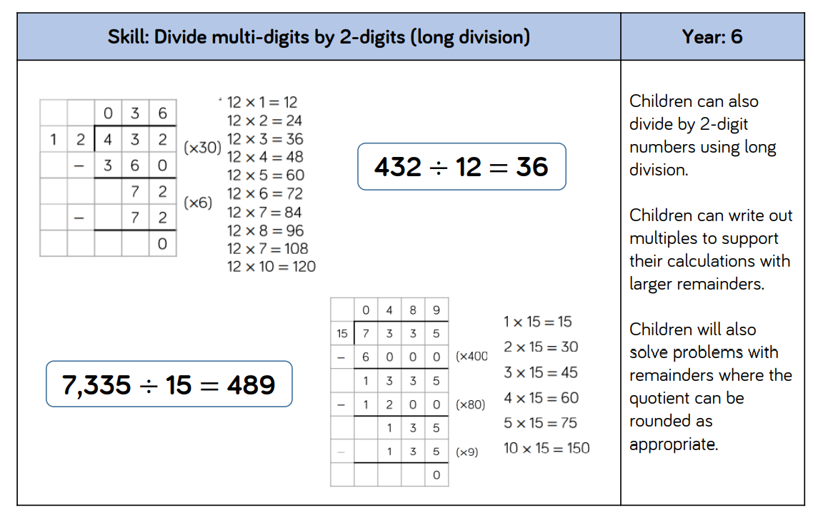
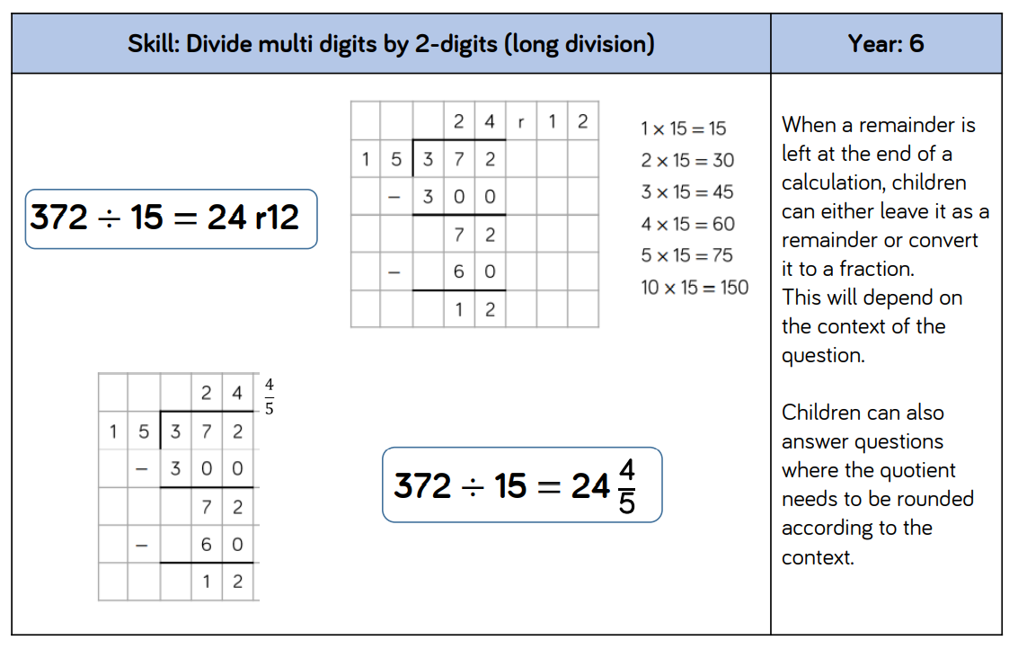

Six School Partnership – Progression through the maths curriculum in our school UPDATED – 6.10.20
Rec | Y1 | Y2 | Y3 | Y4 | Y5 | Y6 | Y7
Place Value - Counting
- Count, recognise and order numbers to 20  -to use one to one correspondence (touch each object and give it a number)  -count objects in a line- beginning to count beyond 10  - Understand when counting, numbers are said in a certain order  -count actions or objects without physically touching them  . Know that the last number said identifies how many are in a set  -count objects in a group/ irregular arrangement.  ( using first same objects/ then different objects)  start from a given number name and stop at another. (start with 2, hold it in your head, count on to 8)  -count on several numbers from a given number (using fingers to help: count on three numbers from 4) | -Count to and across 100, forwards and backwards, beginning with 0 or 1, or from any given number  -Count numbers  to 100 in numerals; count in multiples of twos , fives and tens | -Count in steps of 2, 3, and five and from 0 and in tens from any number, forward and backward | -Count from 0 in multiples of 4, 8, 50 and 100; find 10 or 100 more or less than a given number | -Count in multiples of 6, 7, 9, 25,1000  Count backwards through zero to include negative numbers | -Count forward or backwards in steps of powers of 10 for any given numbers up to 1 000 000
Place value- represent
Rec | Y1 | Y2 | Y3 | Y4 | Y5 | Y6 | Y7
-Identify and represent numbers using objects and pictorial representations | -Identify and represent numbers using objects and pictorial representations  -Read and write numbers to 100 in numerals  -Read and write numbers from 1 to 20 in numerals and words | -Read and write numbers to at least 100 in numerals and in words  -Identify, represent and estimate numbers using different representations, including the number line | -Identify, represent and estimate numbers using different representations  -Read and write number up to 1000 in numerals and in words | -Identify, represent and estimate numbers using different representations  -Read Roman numerals to200 (I to C) and know that over time, the numeral system changed to include the concept of zero and place value | -Read and write,  (order and compare) numbers to at least 1 000 000 and determine the value of each digit  -Read Roman numerals to 1000 (M) and recognise years written in Roman numerals | -Read, write, (order and compare) numbers up to 10 000 000 and determine the value of each digit
Place Value: Use place value and Compare
Rec | Y1 | Y2 | Y3 | Y4 | Y5 | Y6 | Y7
-Compare quantities of identical and non-identical objects  - | Given a number identify one more and one less | Recognise the place value of each digit in a two-digit number (tens, ones)  Compare and order numbers from 0 up to 100; use <,> and = signs | Recognise the place value of each digit in a three-digit number (hundreds, tens, ones)  Compare and order numbers up to 1000 | Find 1000 more or less than a given number  Recognise the place value of each digit in s four-digit number (thousands , hundreds, tens and ones  Order and compare numbers beyond 1000 | (Read, write) order and compare numbers to at least 1 000 000 and determine the value of each digit | (Read, write) order and compare numbers up to 10 000 000 and determine the value of each digit | -order positive and negative integers, decimals and fractions  -use the numberline as a model for ordering integers, decimals and fractions  - use the symbols =, ≠, <, >, ≤, ≥ to make order statements about positive and negative integers, decimals and fractions  -Understand and use place value for decimals, measures and integers of any size  -Understand and use place value for decimals, measures and integers of any size
Place Value: problems and Rounding
Rec | Y1 | Y2 | Y3 | Y4 | Y5 | Y6 | Y7
 |  | -Use place and value and number facts to solve problems | -Solve number problems and practical problems involving these ideas | -Round any number to the nearest 10, 100 or 1000  -Solve number and practical problems that involve all of the above and with increasingly large positive numbers | -Interpret negative numbers in context  -Round any number up to 1 000 000 to the nearest 10, 100, 1000, 10 000 and 100 000  -Solve number problems and practical problems that involved all of the above | -Round any whole number to a required degree of accuracy  -Use negative numbers in context, and calculate intervals across zero  -Solve number and practical problems that involve all of the above | -round numbers and measures to different degrees of accuracy, for example to the nearest whole number or to one decimal place  - round numbers and measures to an appropriate degree of accuracy, for example to the nearest whole number or to one decimal place  - use approximation, through rounding to the nearest whole number or to one decimal place, to estimate answers  -extend their understanding of the number system; make connections between number relationships, and their algebraic and graphical representations
Addition and Subtraction: Recall, Represent, Use
Rec | Y1 | Y2 | Y3 | Y4 | Y5 | Y6 | Y7
-rapid recall of doubles  -use of songs and rhymes to do 1 more and 1 less | -Read and write and interpret mathematical statements involving addition (+), subtraction (-) and equals (=) signs  -Represent and use number bonds related subtraction facts within 20 | -Recall and use addition and subtraction facts to 20 fluently, and derive and use related facts up to 100  -Show that addition of two numbers can be done in any order (commutative) and subtraction of one number from another cannot  -Recognise and use the inverse relationship between addition and subtraction and use this to check calculations and solve missing number | -Estimate the answer to a calculation and use inverse operations to check answers | -Estimate and use inverse operations to check answers to a calculation | -Use rounding to check answers to calculations and determine, in the context of a problem, levels of accuracy
Addition and Subtraction: calculations
Rec | Y1 | Y2 | Y3 | Y4 | Y5 | Y6 | Y7
-recognise and name + and - and = signs  -read an addition number sentence  -solve an addition number sentence  - arrange an addition number sentence  -read a subtraction number sentence  -solve a subtraction number sentence  -calculate by adding 2 single digit numbers and count on or back to find the answer | -Add and subtract one-digit and two-digit numbers to 20 including zero | -Add and subtract numbers using concrete objects, pictorial representations and mentally, including:  A two-digit number and ones  A two-digit number an tens  Two two-digit numbers  Adding three one-digit numbers | -Add and subtract numbers mentally, including:  A three-digit number and ones  A three digit number and tens  A three digit number and hundreds  Add and subtract numbers with up to three digits, using formal written methods of columnar addition and subtraction | -Add and subtract numbers with up to 4 digits using the formal written methods of columnar addition and subtraction where appropriate | -Add and subtract whole numbers with more than 4 digits, including using formal written methods (columnar addition and subtraction)  Add and subtract numbers mentally with increasingly large numbers | -Perform mental calculations, including with mixed operations and large numbers  -Use their knowledge of the order of operation to carry out of calculations involving the four operations | -use the four operations, including formal written methods, applied to integers and decimals; multiply proper and improper fractions, and mixed numbers, all both positive and negative  -recognise and use relationships between the operations +, –, ×, ÷, including inverse operations
Addition and Subtraction –Solve Problems
Rec | Y1 | Y2 | Y3 | Y4 | Y5 | Y6 | Y7
-use number to solve problems  -using concrete objects to sort into groups based on size, colour or shape  -Solve problems and know that a group of things changes quantity when something is added or taken away  -use language of difference, more/less | -Solve one-step problems that involve addition and subtraction, using concrete objects and pictorial representations, and missing number problems such as 7 = - 9 | -Solve problems with addition and subtraction:  Using concrete objects and pictorial representations, including those involving numbers, quantities and measures  -Applying their increasing knowledge of mental and written methods | -Solve problems including missing number problems using number facts, place value, and more complex addition and subtraction | -Solve addition and subtraction two-step problems in contexts, deciding which operations and methods to use and why | -Solve addition and subtraction multi-step problems in contexts, deciding which operations and methods to use and why  Solve problems involving addition, subtraction, multiplication and division and a combination of these, including understanding the meaning of the equals sign | -Solve addition and subtraction multi-step problems in contexts deciding which operations and methods to use and why
Multiplication and Division – Recall, Represent, Use
Rec | Y1 | Y2 | Y3 | Y4 | Y5 | Y6 | Y7
-count in tens (recite the sequence ten, twenty, thirty… one hundred.) Do the same backwards  -rapid recall of doubles  -count patterns involving equal groups | count in twos, fives and tens (recite the sequences and do the same backwards | -Recall and use multiplication and division facts for the 2, 5 and 10 multiplication tables, including recognising odd and even numbers  -Show that multiplication of two numbers can be done in any order (commutative) and division of one number by another cannot | -Recall and use multiplication and division facts for 3, 4 and 8 multiplication tables | -Recall multiplication and division facts for multiplication tables up to 12 x 12  -Use place value, known and derived facts to multiply and divide mentally, including: multiplying by 0 and 1; dividing by 1; multiplying together three numbers  -Recognise and use factor pairs and commutativity in mental calculations | -Identify multiples and factors, including finding all factor pairs of a number, and common factors of two numbers  -Know and use the vocabulary of prime numbers, prime factors and composite (non-prime) numbers  -Establish whether a number up to 100 is prime and recall prime numbers up to 19  -Recognise and use square numbers and cube numbers, and the notation for squared(²)and cubed (³) | -Identify common factors, common multiples and prime numbers  -Use estimation to check answers to calculations and determine, in the context of a problem, and appropriation degree of accuracy. | -recognise and use relationships between the operations +, –, ×, ÷, including inverse operations
Multiplications and Division: Calculations
Rec | Y1 | Y2 | Y3 | Y4 | Y5 | Y6 | Y7
 |  | -Calculate mathematical statements for multiplication and division within the multiplication tables and write them using the multiplication (x), division (÷) and equal (=) signs | -Write and calculate mathematical statements for multiplication and division using multiplication tables that they know, including for two-digit numbers times one-digit numbers, using mental and progressing to formal written methods | -Multiply two-digit and three-digit numbers by a one-digit number using formal written layout | -Multiply numbers up to 4 digits by a one-or two-digit number using a formal written method, including long multiplication for two-digit numbers  -Multiply and divide numbers mentally drawing upon known facts  -Divide numbers up to 4 digits by a one- digit number using the formal written method of short division and interpret remainders appropriately for the context  -Multiply and divide whole numbers and those involving decimals by 10, 100, and 1000 | -Multiply multi-digit numbers up to 4 digits by a two-digit whole number using the formal written method of long multiplication  -Divide numbers up to 4 digits by a two-digit whole number using the formal written method of long division, and interpret remainders as whole number remainders, fractions, or by rounding as appropriate for the context  -Divide numbers up to 4 digits by a two-digit number using the formal written method of short division where appropriate, interpreting remainders according to the context  -Perform mental calculations, including with mixed operations and large numbers | -use the four operations, including formal written methods, applied to integers and decimals; multiply proper and improper fractions, and mixed numbers, all both positive and negative
Multiplication and Division: Solve Problems
Rec | Y1 | Y2 | Y3 | Y4 | Y5 | Y6 | Y7
-solve real life problems involving doubling, halving and sharing  -Represent mathematical thinking through pictures and drawings | -Solve one-step problems involving multiplication and division, by calculating the answer using concrete objects, pictorial representation and arrays with the support of the teacher | -Solve problems involving multiplication and division, using materials, arrays, repeated addition, mental methods, and multiplication and division facts, including problems in contexts | -Solve problems including missing number problems, involving multiplication and division, including positive integer scaling problems and correspondence problems In which n objects are connected to m objects | -Solve problems involving multiplying and adding, including using the distributive law to multiply two digit numbers by one digit, integer scaling problems and harder correspondence problems such as n objects are connected to m objects | -Solve problems involving multiplication and division including using their knowledge of factors and multiples, squares and cubes  Solve problems involving multiplication and division, including scaling by simple fractions and problems involving simple rates | -Solve problems involving addition, subtraction, multiplication and division | -use the concepts and vocabulary of prime numbers, factors (or divisors), multiples, common factors, common multiples, highest common factor, lowest common multiple  use square, cube, square root and cube root
Multiplication and Division – Combined Operations
Rec | Y1 | Y2 | Y3 | Y4 | Y5 | Y6 | Y7
 |  |  |  |  | -Solve problems involving addition, subtraction, multiplication and division and a combination of these, including understanding the meaning of the equals sign | -Use their knowledge of the order of operations to carry out calculations involving the four operations | -use conventional notation for the priority of operations, including brackets  -recognise and use relationships between the operations +, –, ×, ÷, including inverse operations  - express one quantity as a whole-number multiple of another, and by reversing the expression of the same relationship express one quantity as a unit fraction of another
Fractions: Recognise and Write
Rec | Y1 | Y2 | Y3 | Y4 | Y5 | Y6 | Y7
-share a quantity of objects between two.  -Identify half a group of objects  -Identify half a shape (not always circular)  -Put together halves to make whole shapes  -Break an object in half  -Begin to count to ten in halves. (zero, half, one, one and a half, two, two and a half, three, three and a half…) | -Recognise, find and name a half as one of two equal parts of an object, shape or quantity  -Recognise, find and name a quarter as one of four equal parts of an object, shape or quantity | -Recognise, find, name and write fractions $\frac{1}{3}$ , $\frac{1}{4}$, $\frac{2}{4}$ and $\frac{3}{4}$ of a length, shape, set of objects or quantity | -Count up and down in tenths; recognise that tenths arise from dividing an object into 10 equal parts and in dividing one-digit numbers or quantities by 10  -Recognise, find and write fractions of a discrete set of objects: unit fractions and non-unit fractions with small denominators  -Recognise and use fractions as numbers: unit fractions and non-unit fractions with small denominators | -Count up and down in hundredths; recognise that hundredths arise when dividing an object by one hundred and dividing tenths by ten. | -Identify, name and write equivalent fractions of a given fraction, represented visually, including tenths and hundredths  -Recognise mixed numbers and improper fractions and covert from one form to the other and write mathematical statements > 1 as a mixed number [for example, $\frac{2}{5}$ + $\frac{4}{5}$ = $\frac{6}{5}$ = $1\frac{1}{5}$]
Fractions: Compare
Rec | Y1 | Y2 | Y3 | Y4 | Y5 | Y6 | Y7
. |  | -Recognise the equivalence of $\frac{2}{4}$ and $\frac{1}{2}$ | -Recognise and show, using diagrams, equivalent fractions with small denominators  -Compare and order unit fractions, and fractions with the same denominators | -Recognise and show, using diagrams, families of common equivalent fractions | -Compare and order fractions whose denominators are all multiples of the same number | -Use common factors to simplify fractions; use common multiples to express fractions in the same denomination  -Compare and order fractions; including fractions >1 | -define percentage as ‘number of parts per hundred’, and know their decimal and fraction equivalents  -work interchangeably with terminating decimals and their corresponding fractions (such as 3.5 and 7/2 or 0.375 and 3/8)  express one quantity as a whole-number multiple of another, and by reversing the expression of the same relationship express one quantity as a unit fraction of another
Fractions: Calculations
Rec | Y1 | Y2 | Y3 | Y4 | Y5 | Y6 | Y7
Can recognise ‘fair share’ of an item e.g. a banana or a set of objects  -can describe a part and a whole e.g. a piece of cake / pizza and a whole cake / pizza |  | -Write simple fractions for example, $\frac{1}{2}$ of 6 = 3 | -Add and subtract fractions with the same denominator within one whole [for example, $\frac{5}{7}+\frac{1}{7}=\frac{6}{7}$] | -Add and subtract fractions with the same denominator | -Add and subtract fractions with the same denominator and denominators that are multiples of the same number  -Multiply proper fractions and mixed numbers by whole numbers, supported by materials and diagrams | -Add and subtract fractions with different denominators and mixed numbers using the concept of equivalent fractions  -Multiply simple pairs of proper fractions, writing the answer in the simplest form [for example, $\frac{1}{4}x\frac{1}{2}=\frac{1}{8}$ ]  Divide proper fractions by whole numbers [for example, $\frac{1}{3}÷2=\frac{1}{6}$ ]
Fractions: Solve Problems
Rec | Y1 | Y2 | Y3 | Y4 | Y5 | Y6 | Y7
 |  |  | -Solve problems that involve all of the above | -Solve problems involving increasingly harder fractions to calculate quantities and fractions to divide quantities, including non-unit fractions where the answer is a whole number |  |  | -recognise and use relationships between the operations +, –, ×, ÷, including inverse operations  - express one quantity as a whole-number multiple of another, and by reversing the expression of the same relationship express one quantity as a unit fraction of another
Decimals: Recognise and Write
Rec | Y1 | Y2 | Y3 | Y4 | Y5 | Y6 | Y7
 |  |  |  | -Recognise and write decimal equivalents of any number of tenths or hundredths  -Recognise and write decimal equivalents to $\frac{1}{4},\frac{1}{2},\frac{3}{4}$ | -Read and write decimal numbers as fraction [for example, 0.71=$\frac{71}{100}$]  -Recognise and use thousandths and relate them to tenths, hundredths and decimal equivalents | -Identify the value of each digit in numbers given to three decimal places
Decimals: Compare
Rec | Y1 | Y2 | Y3 | Y4 | Y5 | Y6 | Y7
 |  |  |  | -Round decimals with one decimal place to nearest whole number  -Compare numbers with the same number of decimal places up to two decimal places | -Round decimals with two decimal places to the nearest whole number and to one decimal place  -Read, write, order and compare numbers with up to three decimal places
Decimals: Calculations and Problems
Rec | Y1 | Y2 | Y3 | Y4 | Y5 | Y6 | Y7
 |  |  |  | -Find the effect of dividing a one- or two digit number by 10 and 100, identifying the value of the digits in the answer as ones, tenths and hundredths | -Solve problems involving number up to three decimal places | -Multiply and divide numbers by 10, 100 and 1000 giving answers up to three decimal places  -Multiply one-digit numbers with up to two decimal places by whole numbers  -Use written division methods in cases where the answer has up to two decimal places  -Solve problems which require answers to be rounded to specified degrees of accuracy
Fractions, Decimals and Percentages
Rec | Y1 | Y2 | Y3 | Y4 | Y5 | Y6 | Y7
 |  |  |  | -Solve simple measures and money problems involving fractions and decimals to two decimal places | -Recognise the per cent symbol (%) and understand that per cent relates to ‘number of parts per hundred’, and write percentages as a fraction with denominator 100, and as a decimal  -Solve problems which require knowing percentage and decimal equivalents of $\frac{1}{2},\frac{1}{4},\frac{1}{5},\frac{2}{5},\frac{4}{5}$ and those fractions with a denominator of a multiple of 10 or 25 | -Associate a fraction with division and calculate decimal fraction equivalents [for example, 0.375] for a simple fraction [for example, $\frac{3}{8}$]  -Recall and use equivalences between simple fractions, decimals and percentages, including in different contexts | -define percentage as ‘number of parts per hundred’, and know their decimal and fraction equivalents  -work interchangeably with terminating decimals and their corresponding fractions (such as 3.5 and 7/2 or 0.375 and 3/8)  express one quantity as a whole-number multiple of another, and by reversing the expression of the same relationship express one quantity as a unit fraction of another
Ratio and Proportion
Rec | Y1 | Y2 | Y3 | Y4 | Y5 | Y6 | Y7
 |  |  |  |  |  | -Solve problems involving the relative sizes of two quantities where missing values can be found by using integer multiplication and division facts  -Solve problems involving the calculation of percentages [for example, of measures, and such as 15% of 360] and the use of percentages for comparison  -Solve problems involving similar shapes where the scale factor is known or can be found  -Solve problems involving unequal sharing and grouping using knowledge of fractions and multiples. | -express one quantity as a whole-number multiple of another, and by reversing the expression of the same relationship express one quantity as a unit fraction of another  - understand that a multiplicative relationship between two quantities that can be expressed as a ratio of the form 1 : n where n is an integer can also be expressed as the unit fraction 1/n  - use ratio notation, including reduction to simplest form  - use scale factors of scale diagrams and maps in everyday contexts  - relate the language of ratios and the associated calculations to the arithmetic of fractions  - relate dividing a given quantity into two parts in a given part:whole ratio to finding a fraction of a quantity; relate part:part ratios of quantities to the corresponding part:whole ratios  -use the idea of compound units (A ‘per’ B), as in unit pricing, to solve problems
Algebra
Rec | Y1 | Y2 | Y3 | Y4 | Y5 | Y6 | Y7
-Problem solving that involves sequencing and recognising patterns | Solve on-step problems that involve addition and subtraction, using concrete objects and pictorial representations, and missing number problems such as  7= - 9 | Recognise and use the inverse relationship between addition and subtraction and use this to check calculations and solve missing number problems | Solve problems including missing number problems |  |  | Use simple formulae  Generate and describe linear number sequences  Express missing number problems algebraically  Find pairs of numbers that satisfy an equation with two unknowns  Enumerate possibilities of combinations of two variables | use and interpret algebraic notation, including:  ab in place of a × b, 3y in place of y + y + y and 3 × y  a2 in place of a × a, a3 in place of a × a × a; a2b in place of a × a × b  a/b in place of a ÷ b brackets  - understand the correct and incorrect use of ‘=’;  understand and use the concepts and vocabulary of expressions, equations, inequalities, terms and factors  - simplify and manipulate algebraic expressions to maintain equivalence by:  -collecting like terms  -multiplying a single term over a bracket  -use algebraic methods to solve linear equations in one variable  - interpret simple linear mathematical relationships, such as y equals 5 times x or p is 3 more than twice q, both algebraically and graphically  -substitute positive integer values into formulae and expressions, including scientific formulae  - understand and use standard mathematical formulae  -model simple situations or procedures involving two variables by translating them into linear algebraic expressions or formulae and by using graphs  - generate terms of a sequence with a simple linear position-to-term rule (such as ‘an expression for the value of the nth term is n + 2’) from either the term-to-term or the position-to-term rule
Measurement: Using Measures
Rec | Y1 | Y2 | Y3 | Y4 | Y5 | Y6 | Y7
use every day language to compare quantities and objects.  order two items by mass (using everyday language)  order two or three items by length or height.  use everyday language to compare quantities and objects and talk about distance.  order two items by capacity (using everyday language).  -order and sequences familiar events.  -use everyday language related to time (days of week & begins to identify o’clock).  use everyday language to talk about money.  demonstrates understanding that £1 has greater value than pennies.  know and name different coins – 1p, 2p, 5p, 10p, 20p, 50p, £1 and £2.  can use 1p, 5p and 10p coins to make amounts up to 20 | -Compare, describe and solve practical problems for:  - Lengths and heights [for example, long/ short, longer/ shorter, tall/ short, double/half]  - Mass/weight [for example, heavy/light, heavier than, lighter than]  - Capacity and volume [for example full/empty, more than, less than, half, half full, quarter  - Time [for example, quicker, slower, earlier, later]  -Measure and begin to record the following:  Lengths and heights  Mass/weight  Capacity and volume  Time(hours, minutes, seconds) | -Choose and use appropriate standard units to estimate and measure lengths/ height in any direction (m/cm); mass (kg/g); temperature ($℃$ ); capacity (litres/ml) to the nearest appropriate unit, using rulers, scales thermometers and measuring vessels  -Compare and order lengths, mass, volume/ capacity/ and record the results using >, < and = | -Measure and compare, add and subtract: lengths ( m/cm/mm); mass (kg/g); volume/ capacity (l/ml) | -Convert between different units of measure [for example, kilometre to metre; hour to minute]  Estimate, compare and calculate different measures | -Convert between different units of metric measure (for example, kilometre and metre centimetre and metre ; centimetre and millimetre; gram and kilogram; litre and millilitre)  -Understand and use approximate equivalences between metric units and common imperial units such as inches, pounds and pints  -Use all four operations to solve problems involving measure [for example, length, mass, volume, money]using decimal notation, including scaling | -Solve problems involving the calculation and conversion of units of measure, using decimal notation up to three decimal places where appropriate  -Use, read, write and convert between standard units, converting measurements of length, mass, volume and time from a smaller unit of measure to a larger unit, and vice versa, using decimal notation to up to three decimal places  -Convert between miles and kilometres | -change freely between related standard units, for example:  time (4 hours = 4 × 360 seconds),  length (7 mm = 7 × 0.1 cm),  area (9 m2 = 9 × 10000 cm2),  volume/capacity (3 mm3 = 3 x 0.001 cm3) ,  mass (5 kg = 5 × 1000 g)  - use standard units of mass, length, time, money and other measures, including with decimal quantities
Measurement: Money
Rec | Y1 | Y2 | Y3 | Y4 | Y5 | Y6 | Y7
-Understand that coins can be used to buy things  -Use coins in real life and practical contents  -recognise names and know the value of different coins  -Know an item can be used to represent more than one object e.g. 2p coin | -Recognise and know the value of different denominations of coins and notes | -Recognise and use symbols for pounds (£) and pence (p); combine amounts to make a particular value  -Find different combinations of coins that equal the same amounts of money  -Solve simple problems in a practical context involving addition and subtraction of money of the same unit, including giving change | -Add and subtract amounts of money to give change, using both £ and p in practical contexts | -Estimate, compare and calculate different measures, including money in pounds and pence | -Use all four operations to solve problems involving measure [for example money ]
Measurement: Time
Rec | Y1 | Y2 | Y3 | Y4 | Y5 | Y6 | Y7
-Measure short periods of time in different ways | -Sequence events in chronological order using language [for example, before and after, next, first, today, yesterday, tomorrow, morning, afternoon, and evening]  -Recognise and use language relating to dates, including days of the week, weeks  -Tell the time to the hour and half past the hour and draw the hand on a clock face to show these times | -Compare and sequence intervals of time.  -Tell and write the time to five minutes, including quarter past/ to the hour and draw the hands on a clock face to show these times  -Know the number of minutes in an hour and the number of hours in a day | -Tell and write the time from an analogue clock, including using Roman numerals from I to XII, and 12-hour and 24 hour clocks  -Estimate and read time with increasing accuracy to the nearest minute; record and compare time in terms of seconds, minutes and hours; use vocabulary such as o’clock a.m./p.m., morning, afternoon, noon, and midnight  -Know the number of seconds in a minute and the number of days in a month, year and leap year  -Compare durations of events [for example to calculate the time taken by particular events and tasks] | -Read, write and convert time between analogue and digital 12- and 24 hour clocks  -Solve problems involving converting from hours to minutes; minutes to seconds; years to months; weeks to days | -Solve problems involving converting between units of time | -Use, read, write and convert, between standard units, converting measurement of time from a smaller unit, and vice versa
Measurement: Perimeter, Area, Volume
Rec | Y1 | Y2 | Y3 | Y4 | Y5 | Y6 | Y7
 |  |  | -Measure the perimeter of simple 2-D shapes | -Measure and calculate the perimeter of a rectilinear figure (including squares) in centimetres and metres  Find the area of rectilinear shapes by counting squares | -Measure and calculate the perimeter of composite rectilinear shapes in centimetres and metres  -Calculate and compare the area of rectangles (including squares ), and including using standard units, square centimetres (cm²) and square metres (m²) and estimate the area of irregular shapes  -Estimate volume [for example, using 1 cm³ blocks to build cuboids (including cubes)] and capacity [for example, using water] | -Recognise that shapes with the same areas can have different perimeters and vice versa  -Recognise when it is possible to use formulae for area and volume of shapes  -Calculate, estimate and compare volume of cubes and cuboids using standard units, including cubic centimetres (cm³) and cubic metres (m³), and extending to other units [for example, mm³ and km³] | - derive and apply formulae to undertake calculations and solve problems involving perimeter and area of rectangles
Geometry: 2-D shapes
Rec | Y1 | Y2 | Y3 | Y4 | Y5 | Y6 | Y7
-Select a particular named shape -Begins to use mathematical names and ‘flat’ 2D shapes. -Use familiar objects and common shapes to create and recreate patterns.  -Use mathematical terms to describe 2-D shapes. -Recognise, create and describe patterns.  -Use everyday language to solve problems.-explores characteristics of/uses mathematical language for everyday objects and shapes.  -Understand that regular and irregular shapes can be categorised and ordered in different ways e.g. size, number of sides  -Order and arrange combinations of shapes in patterns and sequences  -Understand that a shape doesn’t change when it’s in a different orientation e.g. a rotated square | -Recognise and name common 2-D shapes [for example, rectangles (including square), circles and triangles | -Identify and describe the properties of 2-D shapes, including the number of sides and line symmetry in a vertical line  -Identify 2-D shapes of the surface of 3-D shapes, [for example a circle on a cylinder and a triangle on a pyramid  -Compare and sort common 2-D shapes and everyday objects | -Draw 2-D shapes | -Compare and classify geometric shapes, including quadrilaterals and triangles, based on their properties and sizes  -Identify lines of symmetry in 2-D shapes presented in different orientations | -Distinguish between regular and irregular polygons based on reasoning about equal sides and angels.  -Use the properties of triangles to deduce related facts and find missing lengths and angles | -Draw 2-D shapes using given dimensions and angles  -Compare and classify geometric shapes based on their properties and sizes  -Illustrate and name parts of circles , including radius, diameter and circumference and know that the diameter is twice the radius | -describe, sketch and draw: points, lines, parallel lines, perpendicular lines, right angles, regular polygons, and other polygons that are reflectively and rotationally symmetric; use conventional terms and notations, such as using ‘dashes’ to indicate equal lengths and (multiple) arrows to indicate parallel lines  - use the standard conventions for labelling the sides and angles of triangle ABC
Geometry:3-D Shapes
Rec | Y1 | Y2 | Y3 | Y4 | Y5 | Y6 | Y7
-Recognise common 3-d shapes e.g. cylinders, cubes, cuboids, spheres  -Know that 2-d shapes can be made from the faces of a 3D shape | -Recognise and name common 3-D shapes [for example, cuboids (including cubes), pyramids and spheres] | -Recognise and name common 3-D shapes [for example, cuboids (including cubes), pyramids and spheres].  Compare and sort common 3-D shapes and everyday objects | -Make 3-D shapes using modelling materials; recognise 3-D shapes in different orientations and describe them |  | -Identify 3-D shapes including cubes and other cuboids, from 2-D representations | -Recognise, describe and build simple 3-D shapes, including making nets
Geometry: Angles and Lines
Rec | Y1 | Y2 | Y3 | Y4 | Y5 | Y6 | Y7
- |  |  | -Recognise angles as a property of shape or a description of a turn identify right angles, recognise that two right angels makes a half-tur, three make three quarters of a turn and four a complete turn; identify whether angles are greater than or less than a right angle  -Identify horizontal and vertical lines and pairs of perpendicular and parallel | -Identify acute and obtuse angles and compare and order angles up to two right angels by size  Identify lines of symmetry in 2-D shapes presented different orientations  -Complete a simple symmetric figure with respect to a specific line of symmetry | -Know angles are measured in degrees; estimate and compare acute, obtuse and reflex angles  -Draw given angles, and measure them in degrees  -Identify:  Angles at a point and one whole turn (total $360°$)  Angles at a point on a straight line and $\frac{1}{2}$a turn (total $180°$)  Other multiples of $90°$ | Find unknown angles in any triangles, quadrilaterals, and regular polygons  Recognise angles where they meet at a point, are on a straight line, or are vertically opposite, and find missing angels | -derive and illustrate properties [for example, equal lengths and angles] of triangles, quadrilaterals, and other plane figures using appropriate language and technologies  --apply the properties of angles at a point, angles at a point on a straight line, vertically opposite angles  - draw and measure line segments and angles in geometric figures; calculate lengths represented by line segments in scale drawings given scale factors as ratios in the form 1 : n, and understand that the lengths are approximate
Geometry: Position and Direction
Rec | Y1 | Y2 | Y3 | Y4 | Y5 | Y6 | Y7
-Can say what is different and what is the same.  -Begins to categorise according to properties such as size.  -Uses positional language (‘below’, ‘above’, ‘next to’, ‘beside’, ‘in front’, ‘behind’ and ‘on top’  -Describes their relative position such as ‘behind’ or ‘next to’.  -Uses everyday language to talk about position .  -Uses everyday language to solve problems. | -Describe position, direction and movement, including whole, half and quarter and three-quarter turns  Summer 3 | -Order and arrange combinations of mathematical objects in patters and sequences  -Use mathematical vocabulary to describe position, direction and movement, including movement in a straight line and distinguishing between rotation as a turn and in terms of right angles for quarter, half and three-quarter turns (clockwise and anti-clockwise) |  | -Describe positions on a 2-D grid ad coordinates in the first quadrant  -Describe movements between positions as translations of a given unit to the left/right and up down  -Plot specified points and draw sides to complete a given polygon | -Identify, describe and represent the position of shape following a reflection or translation, using the appropriate language, and know that the shape has not changed | -Describe positions on the full coordinate grid (all four quadrants)  -Draw and translate simple shapes on the coordinate plane. And reflect them in the axes | -work with coordinates in all four quadrants  -model simple situations or procedures involving two variables by translating them into linear algebraic expressions or formulae and by using graphs  - apply translations, rotations and reflections to given figures, and identify examples of translations, rotations and reflections (for example, be able to pick out from a group of shapes those that are translations, rotations or reflections of a given shape)
Statistics: Present and Interpret
Rec | Y1 | Y2 | Y3 | Y4 | Y5 | Y6 | Y7
 |  | -Interpret and construct simple pictograms, tally charts, block diagrams and simple tables | -Interpret and present data using bar charts, pictograms and tables | -Interpret and present discrete and continuous data using appropriate graphical methods, including bar charts and time graphs | -Complete, read and interpret information in tables including timetables | -Interpret and construct pie charts and line graphs and use these to solve problems | - produce graphs of linear functions of one variable with appropriate scaling, using equations in x and y and the Cartesian plane  - use linear graphs to estimate values of y for given values of x and vice versa  - from given linear graphs find approximate answers to simple contextual questions  - construct and interpret frequency tables, bar charts, pie charts, and pictograms for simple categorical data, and vertical line (or bar) charts for small sets of ungrouped numerical data and numerical data grouped into a small number of groups
Statistics: Solve Problems
Rec | Y1 | Y2 | Y3 | Y4 | Y5 | Y6 | Y7
 |  | -Ask and answer simple questions by counting the number of objects in each category and sorting the categories by quantity  -Ask and answer questions about totalling and comparing categorical data | -Solve one-step and two-step questions [for example, ‘How many more?’ and ‘How many fewer?’]  -Using information presented in scaled bar charts and pictograms and tables | -Solve comparison, sum and difference problems using information presented in bar charts, pictograms, tables and other graphs | -Solve comparison sum and difference problems using information presented in a line graph | -Calculate and interpret the mean as an average | -describe, interpret and compare observed distributions of a single variable through: appropriate graphical representation involving discrete, including grouped, data; and appropriate measures of central tendency (mean, mode, median) and spread (range)  - describe mathematical relationships between two variables that are easily visible in the data derived from experiments or observations

Maths Assessment Statements
Year 1
Name:

Expected standard Year 1
Statements of assessment | February | July
Place Value
Count
Count to and across 100, forwards and backwards, beginning with 0 or 1, or from any given number
Count numbers to 100 in numerals;
Count in multiples of twos, fives and tens
Represent
Identify and represent numbers using objects and pictorial representations
Read and write numbers to 100 in numerals
Read and write numbers from 1 to 20 in numerals and words
Use and Compare
Given a number, identify one more and one less
Addition and Subtraction
Calculations
Add and subtract one-digit and two digit numbers to 20, including zero
Problems
solve one-step problems involving multiplication and division, by calculating the answer using concrete objects, pictorial representations and arrays with the support of the teacher
Multiplication and Division
Count forwards and backwards in multiples of 2, 5 and 10, up to 10 multiples, beginning with any multiple, and count forwards and backwards through the odd numbers
Problems
Solve one-step problems involving multiplication and division, by calculating the answer using concrete objects, pictorial representations and arrays with the support of the teacher
Fractions
Recognise and write
Recognise, find and name a half as one of two equal parts of an object, shape or quantity
Recognise, find and name a quarter as one of four equal parts of an object, shape or quantity
Algebra
Solve one-step problems that involve addition and subtraction, using concrete objects and pictorial representations, and missing number problems such as
7 = -9
Measurement
Using Measures
Compare, describe and solve practical problems for:
- lengths and heights
- mass/weight
- capacity and volume and time
Measure and begin to record the following:
- lengths and heights
- mass/weight
- capacity and volume
- time (hours, minutes, seconds)
Money
Recognise and know the value of different denominations of coins and notes
Time
Sequence events in chronological order using language [for example, before and after, next, first, today, yesterday, tomorrow, morning, afternoon and evening
Recognise and use language relating to dates, including days of the week, weeks, months and years
Tell the time to the hour and half past the hour and draw the hands on a clock face to show
Geometry
2-D shapes
Recognise and name common 2- D shapes [for example, rectangles (including squares), circles and triangles]
3-D shapes
Recognise and name common 3- D shapes [for example, cuboids (including cubes), pyramids and spheres
Position and Direction
Describe position, direction and movement, including whole, half, quarter and three-quarter turns

February assessment point

On track to ______________________________

July assessment point

________________________________________________

Maths Assessment Statements
Year 2
Name:

Expected standard Year 2
Statements of assessment | February | July
Place Value
Count
Count in steps of 2, 3, and 5 from 0, and in tens from any number, forward and backward
Represent
Read and write numbers to at least 100 in numerals and in words
Identify, represent and estimate numbers using different representations, including the number line
Use and Compare
Recognise the place value of each digit in a two-digit number (tens, ones)
Compare and order numbers from 0 up to 100; use and = signs
Problems / Rounding
Use place value and number facts to solve problems
Addition and Subtraction:
Calculations
Add and subtract numbers using concrete objects, pictorial representations, and mentally, including:
- a two-digit number and ones
- a two-digit number and tens
- two two-digit numbers
- adding three one-digit number
Problems
Solve problems with addition and subtraction:
- using concrete objects and pictorial representations, including those involving numbers, quantities and measures
- applying their increasing knowledge of mental and written methods
Multiplication and Division
Recall / use
Recall and use multiplication and division facts for the 2, 5 and 10 multiplication tables, including recognising odd and even numbers
Show that multiplication of two numbers can be done in any order (commutative) and division of one number by another cannot
Calculations
Calculate mathematical statements for multiplication and division within the multiplication tables and write them using the multiplication (×), division (÷) and equals (=) signs
Problems
Solve problems involving multiplication and division, using materials, arrays, repeated addition, mental methods, and multiplication and division facts, including problems in contexts
Fractions, Decimals and Percentages
Fractions: Recognise and write
Recognise, find, name and write fractions 1/ 3 , 1 / 4 , 2/ 4 and 3/ 4 of a length, shape, set of objects or quantity
Fractions : Compare
Recognise the equivalence of 2 /4 and 1 / 2
Fractions : Calculations
Write simple fractions for example, 1 /2 of 6 =3
Algebra
Recognise and use the inverse relationship between addition and subtraction and use this to check calculations and solve missing number problems
Measurement
Using Measures
Choose and use appropriate standard units to estimate and measure length/height in any direction (m/cm); mass (kg/g); temperature (℃); capacity (litres/ml) to the nearest appropriate unit, using rulers, scales, thermometers and measuring vessels
Compare and order lengths, mass, volume/capacity and record the results using >, < and =
Money
Recognise and use symbols for pounds (£) and pence (p); combine amounts to make a particular value
Find different combinations of coins that equal the same amounts of money
Solve simple problems in a practical context involving addition and subtraction of money of the same unit, including giving change
Time
Compare and sequence intervals of time
Tell and write the time to five minutes, including quarter past/to the hour and draw the hands on a clock face to show these times
Know the number of minutes in an hour and the number of hours in a day
Geometry
2-D shapes
Identify and describe the properties of 2-D shapes, including the number of sides and line symmetry in a vertical line
Identify 2-D shapes on the surface of 3-D shapes, [for example, a circle on a cylinder and a triangle on a pyramid]
Compare and sort common 2-D shapes and everyday objects
3-D shapes
Recognise and name common 3- D shapes [for example, cuboids (including cubes), pyramids and spheres]
Compare and sort common 3-D shapes and everyday objects
Position and Direction
Order and arrange combinations of mathematical objects in patterns and sequences
Use mathematical vocabulary to describe position, direction and movement, including movement in a straight line and distinguishing between rotation as a turn and in terms of right angles for quarter, half and three-quarter turns (clockwise and anticlockwise)
Statistics
Represent and interpret data
Interpret and construct simple pictograms, tally charts, block diagrams and simple tables
Solve Statistical Problems
Ask and answer simple questions by counting the number of objects in each category and sorting the categories by quantity
Ask and answer questions about totalling and comparing categorical data

February assessment point

On track to ______________________________

July assessment point

________________________________________________

Maths Assessment Statements (these statements are not hierarchical)
Year 3
Name:

Expected standard Year 3
Statements of assessment | February | July
Place Value
Count
Count from 0 in multiples of 4, 8, 50 and 100; find 10 or 100 more or less than a given number
Represent
Identify, represent and estimate numbers using different representations
Read and write numbers up to 1000 in numerals and in words
Use and Compare
Recognise the place value of each digit in a three-digit number (hundreds, tens, ones)
Compare and order numbers up to 1000
Problems / Rounding
Solve number problems and practical problems involving these ideas
Addition and Subtraction:
Calculations
Add and subtract numbers mentally, including:
- a three-digit number and ones
- a three-digit number and tens
- a three-digit number and hundreds
- add and subtract numbers with up to three digits, using formal written methods of columnar addition and subtraction
Problems
Solve problems, including missing number problems, using number facts, place value, and more complex addition and subtraction
Multiplication and Division
Recall / use
Recall and use multiplication and division facts for the 3, 4 and 8 multiplication tables
Calculations
Write and calculate mathematical statements for multiplication and division using the multiplication tables that they know, including for two-digit numbers times one-digit numbers, using mental and progressing to formal written method
Problems
Solve problems, including missing number problems, involving multiplication and division, including positive integer scaling problems and correspondence problems in which n objects are connected to m objects
Fractions, Decimals and Percentages
Fractions: Recognise and write
Count up and down in tenths
Recognise that tenths arise from dividing an object into 10 equal parts and in dividing one-digit numbers or quantities by 10
recognise, find and write fractions of a discrete set of objects: unit fractions and non-unit fractions with small denominators
recognise and use fractions as numbers: unit fractions and non-unit fractions with small denominators
Fractions : Compare
Recognise and show, using diagrams, equivalent fractions with small denominators
Compare and order unit fractions, and fractions with the same denominators
Add and subtract fractions with the same denominator within one whole, (for example, 5/7 + 1/7 = 6/7)
Fractions : Solve Problems
Solve problems that involve all of the above
Algebra
Solve problems, including missing number problems
Measurement
Using Measures
Measure, compare, add and subtract:
lengths (m/cm/mm);
mass (kg/g);
volume/capacity (l/ml)
Money
Add and subtract amounts of money to give change, using both £ and p in practical contexts
Time
Tell and write the time from an analogue clock, including using Roman numerals from I to XII, and 12- hour and 24-hour clocks
Estimate and read time with increasing accuracy to the nearest minute; record and compare time in terms of seconds, minutes and hours; use vocabulary such as o’clock, a.m./p.m., morning, afternoon, noon and midnight
Know the number of seconds in a minute and the number of days in each month, year and leap year
Compare durations of events [for example to calculate the time taken by particular events or tasks]
Perimeter, area, volume
Measure the perimeter of simple 2-D shapes
Geometry
2-D shapes
Draw 2-D shapes
3-D shapes
Make 3-D shapes using modelling materials; recognise 3-D shapes in different orientations and describe them
Angles and lines
Recognise angles as a property of shape or a description of a turn
Identify right angles, recognise that two right angles make a half-turn, three make three quarters of a turn and four a complete turn;
Identify whether angles are greater than or less than a right angle
Identify horizontal and vertical lines and pairs of perpendicular and parallel lines
Statistics
Represent and interpret data
Interpret and present data using bar charts, pictograms and tables
Solve Statistical Problems
Solve one-step and two-step questions [for example, ‘How many more?’ and ‘How many fewer?’] using information presented in scaled bar charts and pictograms and tables

February assessment point

On track to ______________________________

July assessment point

________________________________________________

Maths Assessment Statements (these statements are not hierarchical)
Year 4
Name:

Expected standard Year 4
Statements of assessment | February | July
Place Value
Count
Count in multiples of 6, 7, 9, 25 and 1000
Count backwards through zero to include negative numbers
Represent
Identify, represent and estimate numbers using different representations
Read Roman numerals to 100 (I to C) and know that over time, the numeral system changed to include the concept of zero and place value
Use and Compare
Find 1000 more or less than a given number
Recognise the place value of each digit in a four-digit number (thousands, hundreds, tens, and ones)
Order and compare numbers beyond 1000
Problems / Rounding
Round any number to the nearest 10, 100 or 1000
solve number and practical problems that involve all of the above and with increasingly large positive numbers
Addition and Subtraction:

Calculations
Add and subtract numbers with up to 4 digits using the formal written methods of columnar addition and subtraction where appropriate
Multiplication and Division
Recall / use
Recall multiplication and division facts for multiplication tables up to 12 × 12
Use place value, known and derived facts to multiply and divide mentally, including: multiplying by 0 and 1; dividing by 1; multiplying together three numbers
recognise and use factor pairs and commutativity in mental calculations
Calculations
Multiply two-digit and three-digit numbers by a one-digit number using formal written layout
Problems
Solve problems involving multiplying and adding, including using the distributive law to multiply two digit numbers by one digit, integer scaling problems and harder correspondence problems such as n objects are connected to m objects
Fractions, Decimals and Percentages
Fractions: Recognise and write
Count up and down in hundredths; recognise that hundredths arise when dividing an object by one hundred and dividing tenths by ten.
Fractions : Compare
Recognise and show, using diagrams, families of common equivalent fractions
Fractions : Calculations
Add and subtract fractions with the same denominator
Fractions : Solve Problems
Solve problems involving increasingly harder fractions to calculate quantities, and fractions to divide quantities, including non-unit fractions where the answer is a whole number
Decimals: Recognise, write, compare
Recognise and write decimal equivalents of any number of tenths or hundredths
Recognise and write decimal equivalents to 1/4 , 1/2 , 3/4
Round decimals with one decimal place to the nearest whole number
Compare numbers with the same number of decimal places up to two decimal places
Fractions, Decimals and Percentages
Solve simple measure and money problems involving fractions and decimals to two decimal places
Measurement
Using Measures
Convert between different units of measure [for example, kilometre to metre; hour to minute]
Estimate, compare and calculate different measure
Money
Estimate, compare and calculate different measures, including money in pounds and pence
Time
Read, write and convert time between analogue and digital 12- and 24-hour clocks
Solve problems involving converting from hours to minutes; minutes to seconds; years to months; weeks to days
Perimeter, area, volume
Measure and calculate the perimeter of a rectilinear figure (including squares) in centimetres and metres
Find the area of rectilinear shapes by counting squares
Geometry
2-D shapes
Compare and classify geometric shapes, including quadrilaterals and triangles, based on their properties and sizes
Identify lines of symmetry in 2-D shapes presented in different orientations
Angles and lines
Identify acute and obtuse angles and compare and order angles up to two right angles by size
Identify lines of symmetry in 2-D shapes presented in different orientations
Complete a simple symmetric figure with respect to a specific line of symmetry
Position and Direction
Describe positions on a 2-D grid as coordinates in the first quadrant
Describe movements between positions as translations of a given unit to the left/right and up/down
Plot specified points and draw sides to complete a given polygon
Statistics
Represent and interpret data
Interpret and present discrete and continuous data using appropriate graphical methods, including bar charts and time graphs
Solve Statistical Problems
Solve comparison, sum and difference problems using information presented in bar charts, pictograms, tables and other graphs

February assessment point

On track to ______________________________

July assessment point

________________________________________________

Maths Assessment Statements (these statements are not hierarchical)
Year 5
Name:

Expected standard Year 5
Statements of assessment | February | July
Place Value
Count
Count forwards or backwards in steps of powers of 10 for any given number up to 1 000 000
Count forwards and backwards with positive and negative whole numbers, including through zero
Represent
Read, write, (order and compare) numbers to at least 1 000 000 and determine the value of each digit
Read Roman numerals to 1000 (M) and recognise years written in Roman numerals
Use and Compare
(Read, write) order and compare numbers to at least 1 000 000 and determine the value of each digit
Problems / Rounding
Interpret negative numbers in context
Round any number up to 1 000 000 to the nearest 10, 100, 1000, 10 000 and 100 000
Solve number problems and practical problems that involve all of the above
Addition and Subtraction:
Calculations
Add and subtract whole numbers with more than 4 digits, including using formal written methods (columnar addition and subtraction)
Add and subtract numbers mentally with increasingly large numbers
Problems
Solve addition and subtraction multi-step problems in contexts, deciding which operations and methods to use and why
Solve problems involving addition, subtraction, multiplication and division and a combination of these, including understanding the meaning of the equals sign
Multiplication and Division
Recall / use
identify multiples and factors, including finding all factor pairs of a number, and common factors of two numbers
know and use the vocabulary of prime numbers, prime factors and composite (non-prime) numbers
establish whether a number up to 100 is prime and recall prime numbers up to 19
recognise and use square numbers and cube numbers, and the notation for squared (²) and cubed (³)
Calculations
Multiply numbers up to 4 digits by a one- or two-digit number using a formal written method, including long multiplication for two-digit numbers
Multiply and divide numbers mentally drawing upon known facts
Divide numbers up to 4 digits by a one-digit number using the formal written method of short division and interpret remainders appropriately for the context
Multiply and divide whole numbers and those involving decimals by 10, 100 and 100
Problems
Solve problems involving multiplication and division including using their knowledge of factors and multiples, squares and cubes
Solve problems involving multiplication and division, including scaling by simple fractions and problems involving simple rates
Multiplication and division combined
Solve problems involving addition, subtraction, multiplication and division and a combination of these, including understanding the meaning of the equals sign
Fractions, Decimals and Percentages
Fractions: Recognise and write
Identify, name and write equivalent fractions of a given fraction, represented visually, including tenths and hundredths
Recognise mixed numbers and improper fractions and convert from one form to the other and write mathematical statements > 1 as a mixed number [for example, 2/ 5 + 4/ 5 = 6/ 5 = 1 1/ 5]
Fractions : Compare
Compare and order fractions whose denominators are all multiples of the same number
Fractions : Calculations
Add and subtract fractions with the same denominator and denominators that are multiples of the same number
Multiply proper fractions and mixed numbers by whole numbers, supported by materials and diagram
Decimals: Recognise, write, compare
Read and write decimal numbers as fractions [for example, 0.71 = 71 /100 ]
Recognise and use thousandths and relate them to tenths, hundredths and decimal equivalents
Round decimals with two decimal places to the nearest whole number and to one decimal place
Read, write, order and compare numbers with up to three decimal
Fractions, Decimals and Percentages
Recognise the per cent symbol (%) and understand that per cent relates to ‘number of parts per hundred’, and write percentages as a fraction with denominator 100, and as a decimal
Solve problems which require knowing percentage and decimal equivalents of 1 /2 , 1/ 4 , 1/5 , 2/ 5 , 4/ 5 and those fractions with a denominator of a multiple of 10 or 25
Measurement
Using Measures
Convert between different units of metric measure
Understand and use approximate equivalences between metric units and common imperial units such as inches, pounds and pints
Use all four operations to solve problems involving measure [for example, length, mass, volume, money] using decimal notation, including scaling
Money
Use all four operations to solve problems involving measure [for example, money]
Time
Solve problems involving converting between units of time
Perimeter, area, volume
Measure and calculate the perimeter of composite rectilinear shapes in centimetres and metres
Calculate and compare the area of rectangles (including squares) and including using standard units, square centimetres (cm2 ) and square metres (m2 ) and estimate the area of irregular shapes
Estimate volume [for example, using blocks to build cuboids] and capacity [for example, using water]
Geometry
2-D shapes
Distinguish between regular and irregular polygons based on reasoning about equal sides and angles
Use the properties of rectangles to deduce related facts and find missing lengths and angles
3-D shapes
Identify 3-D shapes, including cubes and other cuboids, from 2-D representations
Angles and lines
Know angles are measured in degrees: estimate and compare acute, obtuse and reflex angles
Draw given angles, and measure them in degrees
Identify:
- angles at a point and one whole turn (total 360°)
- angles at a point on a straight line and 1/ 2 a turn (total 180°)
- other multiples of 90°
Position and Direction
Identify, describe and represent the position of a shape following a reflection or translation, using the appropriate language, and know that the shape has not changed
Statistics
Represent and interpret data
Complete, read and interpret information in tables, including timetables
Solve Statistical Problems
Solve comparison, sum and difference problems using information presented in a line graph

February assessment point

On track to ______________________________

July assessment point

________________________________________________

Maths Assessment Statements (these statements are not hierarchical)
Year 6
Name:

Expected standard Year 6
Statements of assessment | February | July
Place Value
Represent
Read, write, (order and compare) numbers up to 10 000 000 and determine the value of each digit
Use and Compare
(Read, write), order and compare numbers up to 10 000 000 and determine the value of each digit
Problems / Rounding
Round any whole number to a required degree of accuracy
Use negative numbers in context, and calculate intervals across zero
Solve number and practical problems that involve all of the above
Addition and Subtraction:
Calculations
Perform mental calculations, including with mixed operations and large numbers
Use their knowledge of the order of operations to carry out calculations involving the four operations
Problems
Solve addition and subtraction multi-step problems in contexts, deciding which operations and methods to use and why
Multiplication and Division
Recall / use
Identify common factors, common multiples and prime numbers
Use estimation to check answers to calculations and determine, in the context of a problem, an appropriate degree of accuracy
Calculations
Multiply multi-digit numbers up to 4 digits by a two-digit whole number using the formal written method of long multiplication
Divide numbers up to 4 digits by a two-digit whole number using the formal written method of long division, and interpret remainders as whole number remainders, fractions, or by rounding, as appropriate for the context
Divide numbers up to 4 digits by a two-digit number using the formal written method of short division where appropriate, interpreting remainders according to the context
Perform mental calculations, including with mixed operations and large numbers
Problems
Solve problems involving addition, subtraction, multiplication and division

Multiplication and division combined
Use their knowledge of the order of operations to carry out calculations involving the four operations
Fractions, Decimals and Percentages

Fractions : Compare
Use common factors to simplify fractions; use common multiples to express fractions in the same denomination
Compare and order fractions, including fractions > 1
Fractions : Calculations
Add and subtract fractions with different denominators and mixed numbers, using the concept of equivalent fractions
Multiply simple pairs of proper fractions, writing the answer in its simplest form [for example,1 4 × 1 2 = 1 /8 ]
Divide proper fractions by whole numbers [for example 1/ 3 ÷ 2 = 1 /6 ]
Decimals: Recognise, write, compare
Identify the value of each digit in numbers given to three decimal places
Fractions, Decimals and Percentages
Associate a fraction with division and calculate decimal fraction equivalents [for example, 0.375] for a simple fraction [for example, 3/ 8 ]
Recall and use equivalences between simple fractions, decimals and percentages, including in different contexts
Ratio and Proportion
Solve problems involving the relative sizes of two quantities where missing values can be found by using integer multiplication and division facts
Solve problems involving the calculation/use of percentages for comparison
Solve problems involving similar shapes where the scale factor is known or can be found
Solve problems involving unequal sharing and grouping using knowledge of fractions and multiples
Algebra
Use simple formulae
Generate and describe linear number sequences
Express missing number problems algebraically
Find pairs of numbers that satisfy an equation with two unknowns
Enumerate possibilities of combinations of two variables
Measurement
Using Measures
Solve problems involving the calculation and conversion of units of measure, using decimal notation up to 3 d.p. where appropriate
Use, read, write and convert between standard units, converting measurements of length, mass, volume and time from a smaller unit of measure to a larger unit, and vice versa, using decimal notation to up to 3 d.p.
Convert between miles and kilometres
Time
Use, read, write and convert between standard units, converting measurements of time from a smaller unit of measure to a larger unit, and vice versa
Perimeter, area, volume
Recognise that shapes with the same areas can have different perimeters and vice versa
Recognise when it is possible to use formulae for area and volume of shapes
Calculate the area of parallelograms and triangles
Calculate, estimate and compare volume of cubes and cuboids using standard units, including cubic centimetres (cm3 ) and cubic metres (m3 ), and extending to other units
Geometry
2-D shapes
Draw 2-D shapes using given dimensions and angles
Compare and classify geometric shapes based on their properties and sizes
Illustrate and name parts of circles, including radius, diameter and circumference and know that the diameter is twice the radius
3-D shapes
Recognise, describe and build simple 3-D shapes, including making nets
Angles and lines
Find unknown angles in any triangles, quadrilaterals, and regular polygons
Recognise angles where they meet at a point, are on a straight line, or are vertically opposite, and find missing angle
Position and Direction
Describe positions on the full coordinate grid (all four quadrants)
Draw and translate simple shapes on the coordinate plane, and reflect them in the axes
Statistics
Represent and interpret data
Interpret and construct pie charts and line graphs and use these to solve problems
Solve Statistical Problems
Calculate and interpret the mean as an average

February assessment point

On track to ______________________________

July assessment point

________________________________________________

